CHAPTER 1: CYBERCRIME – THREAT LANDSCAPE
Recall from Computer Security: definition of
- Vulnerability Something that allows to violate a system, that can be even an intrinsic property
- Asset Something that is considered valuable for an organization
- Threat Potential situations that can violate the system. They may not be directly related to the system itself but to the whole environment.
- Risk statistical and economical evaluation of the exposure to damage because of the presence of vulnerabilities and threats. When building a secure system, we must evaluate and manage risk. Depending on the case (we can even decide that risk = null), we must find a way to manage it. In particular, we are dealing with balancing the risk management with the proposed solution’s expenses and if they are necessary in the specific context in which we are working.
Risk = Asset * Vulnerabilities * Threats. We call Asset * Vulnerabilities as “controllable variables”, where we can work, while we cannot operate on Threats, that are called independent variables. Threats actually tell us which vulnerability to fix
When defining threats, we can make several distinctions. In particular, we can define three dimensions as:
- Internal threats vs External threats. Threats can come either from inside or outside of an organization. Commonly, we tend to consider the external threats as security issues while underestimating the internal ones, but if you have seen Game of Thrones you surely know it is not how it works
- Generic threats vs Targeted/Specific threats. Threats can be taught to target either any user or to a very specific victim (that can be a specific organization, a person etc.). It is a bit harder to describe based on common sense, but we targeted threats can be underestimated, especially for that set of organizations/person/etc. that consider themselves not to be interesting to attackers
- Financially motivated threats and non. When attacks occur, it is almost done for money purposes, hence it is easy to think that “my wallet can be interesting to be stolen” and try to prevent it, while it is harder to think to any other reasons to be targeted. It obviously depends on various aspects (activism, politics, revenge…)
The previous classifications can be summarized in the Gartner quadrant of threats
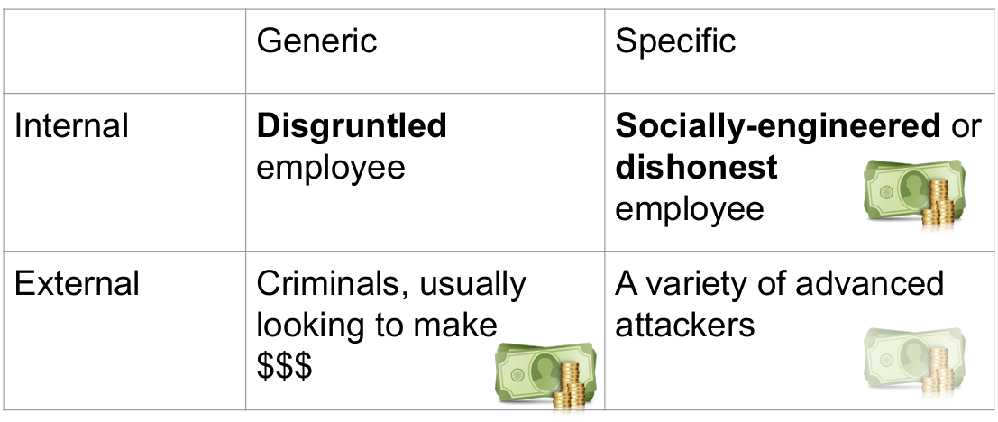
As general feelings, we consider the “internal specific” threats to be the most dangerous, as they can come from someone who knows everything about the organization and how to hurt the victim. But we still underestimate them and focus on defending from external attacks.
In a company, typical security system devices are:
- Firewall (protection against external attacks)
- Antiviruses (protection against generic attacks)
- Authentication mechanism (protection against both internal and external attacks)
Internal threats are generally hard to be defined, since they can also come from “third-party” users (customers, vendors…) that somehow can exploit the system and compromise the security of senisitive information. A simplified list of internal threats can be red in the following image
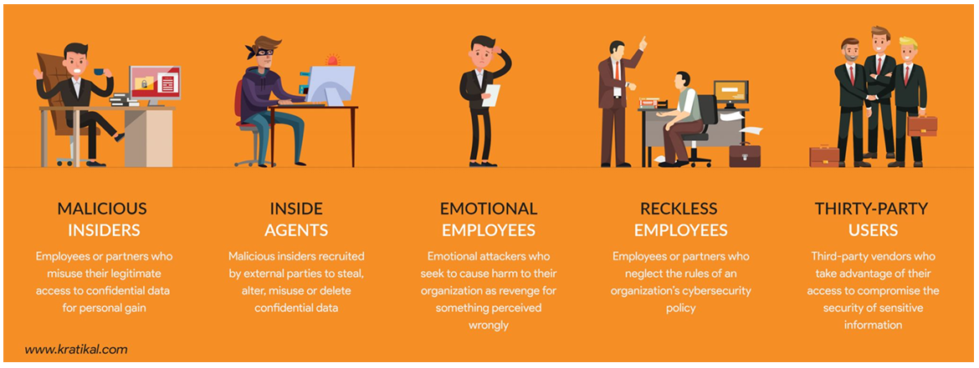
As criminal analyst, when reading certain kinds of information, we need to contextualize them. As an example, let’s have a look at the following graphs. They are telling us that real world breaches almost always related to social engineering components, and human errors that can leave weakness can be causes. Also, external attacks come to appear as the most frequent. Internal attacks should appear to be most dangerous as mentioned earlier, also because of special authorization that makes criminals to easily accede sensitive information, so why do we see them to be less frequent? Possible explanations can easily be “they are trusted agents”, but again careful on the source. They are just reflecting what has actually been documented. An internal attack can easily be hidden, making them not to appear as happened. It can be a consideration, maybe even a wrong one, but the important thing that we must remember is that sources play a very crucial role when analysing certain type of information. In general, when reading those kinds of statistics take in consideration observation bias. And remember that there is almost always something partially wrong with those statistics.
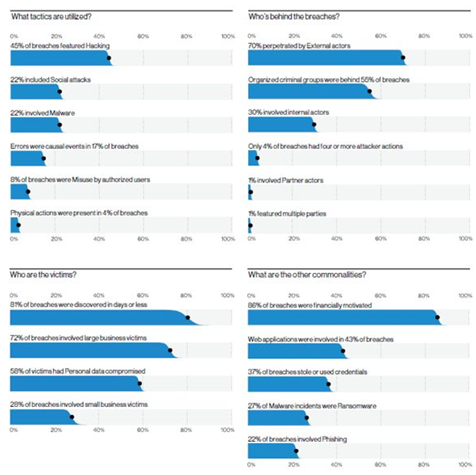
Previously mentioned, Malicious Software (Malwares) are software, codes that are intentionally written to violate a security policy (viruses, worms, trojan horses). Over the time, their goals and motivations has changed a lot. During the early 90s, they were driven by “skill demonstrations”. Next, attacker start target victims for money purposes until when, starting from the 2010, attacks started to aim for new goals: take advantages in a war, political activists and any other non-financially motivated attack.
We will focus on studying the financially oriented attacks. They can appear as direct monetization, that are the “easy way” and involves bank account fraud, ransomwares, fake antiviruses and dialers (malware that monetizes by changing the way a computer dials with the internet), and indirect monetization by means of computing resources abuse, rent or sell botnet infrastructures and similar. We will detail all those techniques and how do they work. Before to do so, remember that there can be different cybercrime structures for different business models. To understand cybercrime, we must see them as a business model themselves.
Fake Antiviruses
The following image provides an example of all fake antiviruses that appear to inform a victim that their computer is compromised and invite them to install the provided “free” antivirus. By doing that, what a user is really installing is a real virus that will infect the computer. Not only files, but also executable components
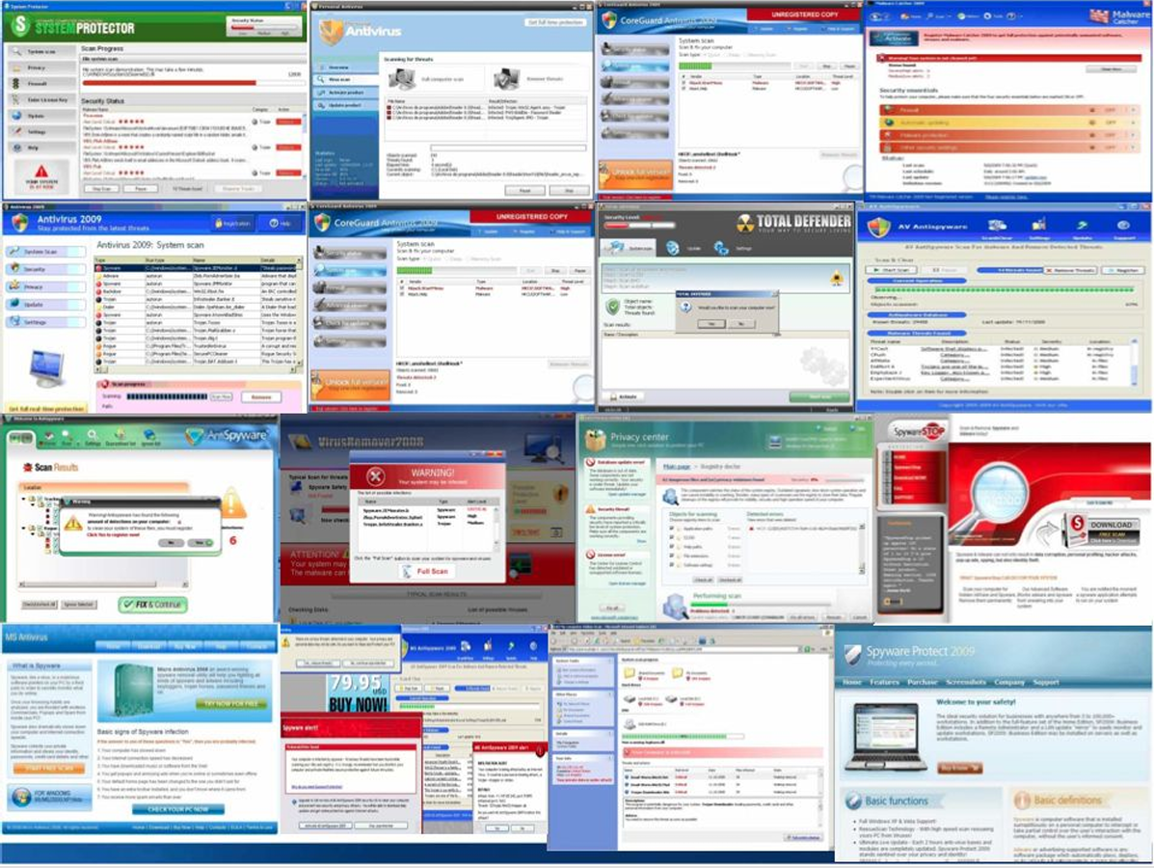
Ransomwares
Ransomwares are a specific type of malwares that partially/totally block the access to the victim’s computer. The attacker, then, asks for a ransom to unlock it. The first developed one was Prototype (1996, against iOS O.S.), but they were not that common. They rose in strength and targets after 2008’s born of bitcoin systems and anonymous cryptocurrencies and, especially, between 2012 and 2013 when a conspicuous amount of people started to use them, making crypto viruses to be interesting for attackers. In fact, the first very successful ransomware is CryptoLocker (2013). In consisted in a generic attack, where a random computer is blocked and attacker asks for money to unlock it. Ransomware attacks can appear in various way; a common one is by sending an apparently safe file to a user that will download and open it. It is important for users to be properly trained to prevent those attacks to succeed.
The encryption mechanisms used by ransomwares are generally different, but they follow similar patterns that can be summarized as follow:
- Using a random AES generated symmetric key, encrypt files that are relevant for a user (important documents, videos, images etc…)
- The symmetric key gets encrypted by an RSA (asymmetric) public key generated by a server. Careful that they can leave tracks about the private key
- The RSA private key is necessary to decrypt the symmetric key and, consequently, the locked files
Since the private keys never reaches the malicious computer, files can be decrypted by the server only.
Some encryptions are performed in the target user’s computer, leaving potential information about the private key. An idea that some ransomwares are based on is to encrypt the original file, copy it and delete the original
Premium calls (dialers)
Those kinds of malwares monetize by changing the way a computer dials with internet going to a “premium page”. This was generally done by acting to the modem, that used to be the intermediate between the computer and the internet, and since modems are not used anymore those types of malwares almost disappeared. They are now present in a different form that attacks mobile phones through SMS
Indirect monetization
There are also some more complex and advanced ways to make money, like acceding and gathering sensitive information to resold, abusing computer resources and renting or selling botnet infrastructures.
Botnet (roBOT + NETwork)
Botnets are a network of compromised computers connected to a malware (a single attacker user) that gain control of all the connected victims and makes them do whatever he wants to do. The idea behind them started with the birth of the Internet Relay Chats IRC.
Originally, IRC were thought to connect to internet channels: the first one to open it is considered as the Master channel and the others are clients. The master can decide what kind of things the clients can do, including exiting the net. If every user in the channel leave, it closes. So, the idea is to install a bot in the connection that behaves as the master and performs automated actions. From a “malicious” point of view, bots can be trained to make constantly run programs that make malicious actions and infect computers connected to the channel. Because of that behaviour, it was used to say that “a botnet is a set of computers connected to a remote zombie”.
A botnet can create different problems: bots are used to perform attacks. Consequently, targets receive Denial of Services. But sometimes the target acquired is not the “real” one, but just an intermediate that will eventually infect the real target. When nets become huge, it can be very difficult to reach back the real attacker.
Drive-by download and its anatomy
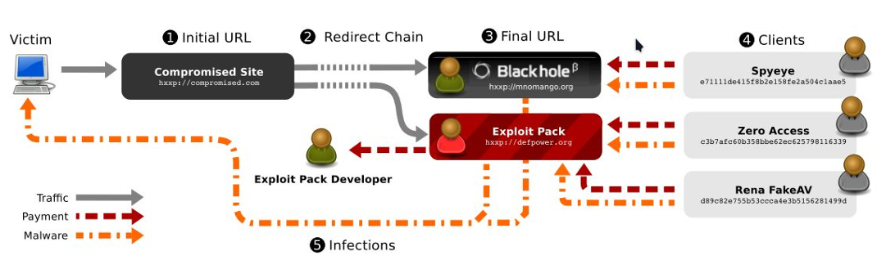
Drive-by download is the definition of the unwanted download of a software: it suffices to open a website to get infected. The graph shown describes the flow of a drive-by download. Here, the “clients” are the attackers.
- The attackers inject the malicious software in a website or even in a spot that appears in legit websites to redirect the traffic to an exploit page
- The browser gets redirected to a landing page controlled by the attackers. This page is part of an exploit kit, and can collect information about the system
- The exploit pack server fingerprints the victim to understand if the system is vulnerable and what kind of attacks can be used
- The exploit is executed, and a malware gets installed
The cybercrime ecosystem
Cybercrimes are generally organized as groups of criminals that work together in different ways. The following image shows and gives an idea about how criminals work together. It is not necessary that all those parts are involved in all the organizations
- Victim
- Attacker (not necessarily a cyber expert)
- Crime services enablers, including malicious server where maliciously collected data are stored and money mules that focus on the financial part of the ecosystem
- Malware developers (that can be the same person/people as the attacker/attackers)
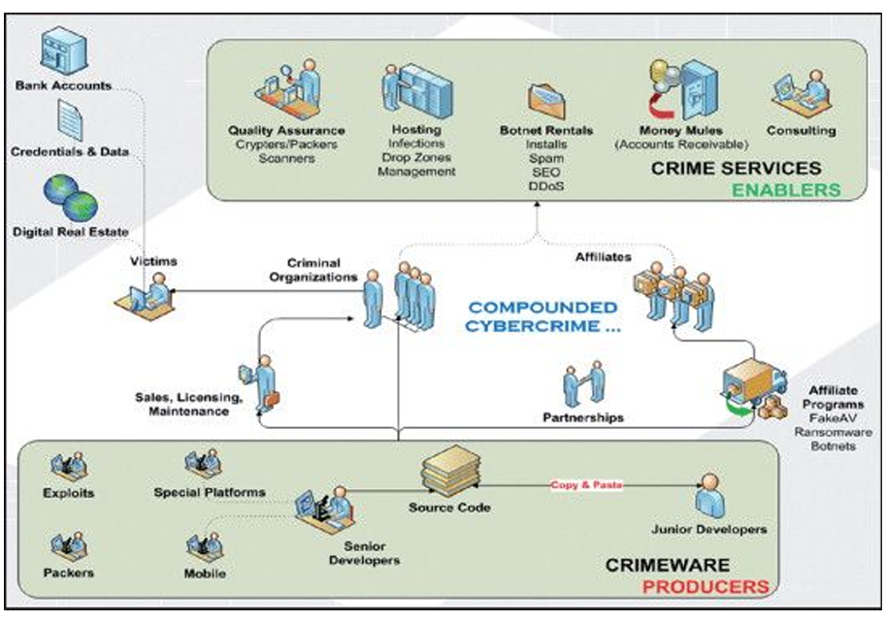
Money-motivated attacks can be described by accessing victim’s bank account, prepare a payment and do it by intercepting authorisation codes. In that case, it can end either by withdrawing the money and making them disappear from the digital traffic or use them digitally by transferring them in different bank accounts (Money mule phenomena), directly using them to buy things or turning them in cryptocurrencies, that are generally anonymous. But also, cryptocurrencies have their disadvantages: firstly, they will, sooner or later, turn back as “real money”. Secondly, the transactions are still visible, and they can be “tracked”.
CHAPTER 2: CRYPTOCURRENCIES – ABUSES AND FORENSICS
BitCoins can be originally defined to solve a significant problem in Computer Science: create a distributed, decentralized ledger (= distributed Database to manage transactions).
They are an information technology breakthrough that define and implement a secure, decentralized payment system and a tool for the storage, verification and auditing of information.
The bitcoin protocol defines an overlay network over Internet that mine bitcoins; each node manages a group of addresses that holds coins; each address is a hashed image of an underlying private-public pair of cryptographic keys and act as a pseudonym of the coin’s holder. The node’s view of this common state is formed by a BlockChain, a shared, append-only, trustable, ledger of all coin’s transactions. The limits of distributed consensus defined in the Byzantine Problem and CAP Theorem are solved using the technique of proof-of-work.
A BitCoin Wallet is a software that allows to manage and store, for each of a user’s bitcoin address, its public and private key, create and sign transactions as receiving/spending bitcoins. Bitcoin address is a string that identifies a public key, and it is used to receive and access the transaction’s history in relation to the address.
Briefly, the bitcoin’s life cycle can be described as follow:
- User A opens his wallet, copy User B’s address, fills the amount and the fee and send the money from one of his public keys (a user can have multiple accounts…)
- The wallet signs the transaction using User A’s private key, ensuring that “User A is actually the owner”.! Keys are used to store and transfer bitcoins
- The transaction is propagated and validated by the network nodes
- Miners include the transaction in the next block to be mined (Miners will be defined later)
- After solving the Proof of Work, the miner propagates the new block to the network
- The nodes verify the result and propagate the block and, eventually, User B sees the first confirmation. New confirmations appear with each new block that is created
Bitcoin chain stores only transactions. It does not know and doesn’t care how many bitcoins are related to a key.
The core concept is related to “occurred transactions”, not about something that is stored somewhere. How to ensure someone cannot transact twice or revert a transaction? We should create a distributed database of transactions that is immutable. The entire state of transactions, that again cannot be rolled back, constitute the current state of where the bitcoins are. This concept is practically shown by defining blockchains.
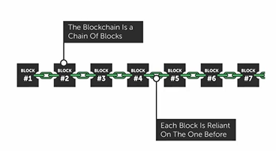
Blocks are a certain number of transactions in a certain timeframe. Blockchain are a linked list of all the blocks, distributed ledger that contains all the transactions that have ever taken place since Bitcoin creation. Ideally each block is reliant on the one that comes before him.
Block Mining

Block mining is the process of “creating new blocks”. Miners compete to generate a new valid block that solves a complex mathematical problem by brute forcing: the solver is then rewarded a fixed number of BTC.
When someone creates transactions, it includes a transaction fee. When we commit to doing a transaction and transfer bitcoins to somebody else, I will also transfer a minimum amount of bitcoin to whoever include the transaction in a block
Nodes validate transactions that occur on the network:
- Miners choose transactions to include in a new block
- Nodes verify all the transactions in the block
- If everything is good, nodes relay the new block to other nodes.
The protocol ensures that the difficulty of finding the next block increases or decreases in relation to the number of miners competing against one another.
Difficulty to create block: solve complex mathematical problems. Hash functions set to start with a pre decided numbers of 0. HASH FUNCTIONS ARE NOT REVERSIBLE
Process: create block add padding obtain hash value see if it starts with the proper number of 0. If it does and the transaction is valid, it is sent. Otherwise, restart

In general, we can think of a block of transactions as a concatenation of its hash value, the number of transactions, the hash of the previous block and other relevant information as seen in the following image
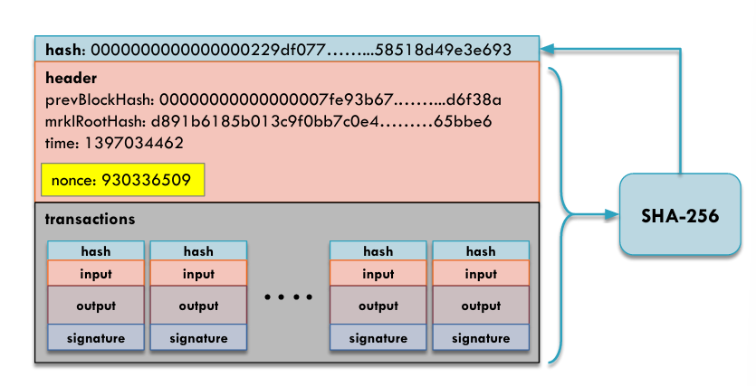
Now, there is an important question we should take care of: how to make sure everyone has the same block?
Imagine two valid transactions starting from different PCs that can both extend the blockchain. Both create different valid “next blocks” based on different collected transactions. They will start to spread their own one, leading to different “next blocks”. What happens when they collide? Potentially, both are valid as “future of the block”. The general rule is to “choose the longest chain of the two (or more)”. The discarded one will be recomputed from the beginning, and everything happened related to the “previous model” is completely discarded (including all the rewards, for something that is considered as “never happened”). The longer a chain gets, the shorter the other ones become.
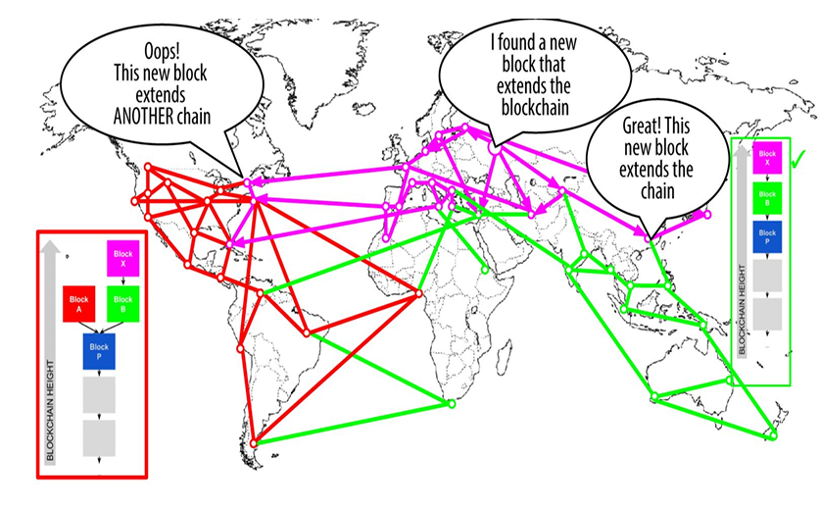
CRIMINALITY
What comes to be important to us is the bitcoins usage in criminality. A first example are “malicious” websites, that accept them as payment currency
Why use them in cybercrime? The main advantages provided by cryptocurrencies in a criminal context are:
- They are a strong infrastructure that can easily be created and managed
- CRYPTO-TRANSACTIONS ARE NOT REVERSIBLE
Their main “problem” is their evident traceability. Since we know the number of transactions that involves a key, everything about it is visible.

A possible solution for maintaining anonymity, or a likely anonymity, is to have different keys, hence different identities (pseudonyms) making it harder to get from all of them to a “real” person (pseudo-anonymity). If a transaction has multiple keys as input, it means we are signing it with a lot of keys, and it is likely that all of them are owned by the same entity.

Cryptocurrencies are decentralized no needs to set up a proper instruction, hence less “risk” for criminals to be detected. Especially, cryptocurrencies are irreversible.
CHAPTER 3: FRAUD ANALYSIS AND DETECTION
Fraud is defined as “wrongful or criminal deception intended to result in financial or personal gain (access to sensitive information…)”, an “uncommon, well-considered, imperceptibly concealed, time-evolving and carefully organized crime which appears in many types of forms”. Fraud is a social phenomenon; it is not necessary to be IT expert to perform such crimes. Characteristics of fraud can be better described as:
- Uncommon Low data and information on it, making it hard to be recognized and to develop a proper counterattack
- Well-considered and imperceptibly concealed Fraudsters try to remain hidden; they try to behave the same as a non-fraudster interaction. They hide very well by well-considering and planning how to precisely commit fraud, built to avoid being detected by the security system
- Time evolving As fraud-detection systems improve and learn by examples, fraud methods change constantly to remain untraced
- Carefully organized crime cybercrime organization follows a precise structure and involves several actors. Cybercriminal ecosystems use “crime-as-a-service” license, that are Malware licenses bought to do specific things
The following flow graph shows the behaviour of an attacker in a context that involves money fraud, that are the most common.
As we see, the “real attacker” is someone that is not actually an IT expert but someone who pays for a “crime-as-a-service” license. It relies on someone able to collect data about storing them in a crime-infrastructure and, finally, the “attack originator” that develops the malware.
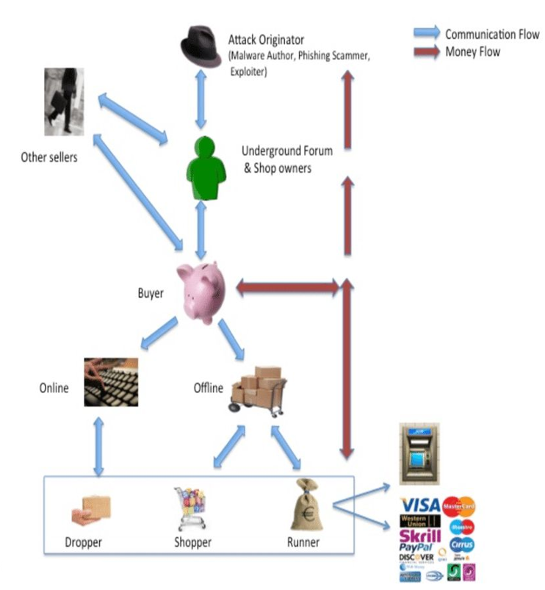
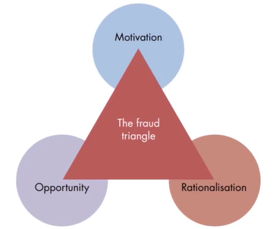
The basic conceptual model that presents the factors that explains the drivers for an individual to commit fraud is represented with the so-called “Fraud Triangle”, whose parts are:
- Motivation, generally monetary (gain/steal or recover losses)
- Opportunity, “clear chance” to securely succeed in an attack
- Rationalization, actually “believe” that the fraud is for a good reason

We can call several kinds of fraud categories, which underlines how that attack can happen in several contexts
A first, obvious example involves banking and credit card fraud, that are basically unauthorized banking operation. Some typical examples are:
- APPLICATION FRAUD: using false IDs, obtain a credit card, spend as much as possible in as less time as possible and then disappear without leaving any trace
- BEHAVIOURAL FRAUD: getting possession of legitimate card details fraudulently
Other examples include insurance frauds, from both sides of the sellers (e.g.: selling policies from non-existent companies) and the buyer (e.g.: fake deaths, fake damages, false medical history…)

As previously mentioned, fraud is a social phenomenon. It can be defined the existence of the Social Engineering, the art of manoeuvring humas to take actions in some aspect of their lives. Attacker uses human behaviours, interact with them, to obtain information. It can be said that humas are the easiest ways to bypass a security protection, rather than trying to find and break a technological vulnerability. PHISHING One of the most common fraud techniques, it is the process of attempting to acquire sensitive information by masquerading as a trustworthy entity in an electronic environment
VISHING Or Voice Phishing, is an “evolution” of the previously describe technique that exploits phone calls and, acting as a trusted source, gain personal informations
ANTI-FRAUD STRATEGY: FRAUD PREVENTION AND DETECTION
Although the two operations are complementary to each other, they are non-independent. They are somehow related, as we’ll see. Fraud detection consists in recognizing or discovering fraudulent activities, while prevention works on trying to prevent fraud events to happen. We say they are related in sense that prevention tries to “study” the attacker’s behaviour and build mechanism that stops him, but when he changes his behaviours detection mechanism comes to be necessary. And vice versa, a detection system actually “learns” attacker’s behaviour, turning to be “similar” to a prevention mechanism.
Fraud detection approaches generally work on a “threefold” approach, based on different user levels (local profiles, temporal profiles, global profiles…)
Local profile characterizes each user’s individual spending pattern to evaluate the anomaly of each new transaction; Global profile characterizes classes of spending patterns and mitigate the undertraining problem; Temporal profile deals with frauds that exploit the repetition of legitimate looking transactions over time.
Fraud prevention approaches look, for example, in ensuring strong authentication mechanisms for most of the operations (payments, login etc.). Nowadays, authentication requirements want at least two levels of authentications (2FA, exploiting two of “classic password”, “one-time passwords” and “biometrical authentications”)
Phones come to be the most vulnerable devices to those attacks, as they are constantly communicating with other devices, and their generally weaker hardware and architectural characteristics.
A historic, popular mobile phone scam phenomena involve sim, in particular sim swapping, that occurs when a fraudster takes control of a mobile phone’s SIM card using stolen personal information of a certain user. Such information can be publicly found (shopping websites, social media…) and, with them, an attacker dupes the mobile phone operator in porting the victim’s mobile number to a SIM in his possession and then, he can receive calls and messages to his phones, including the victim online banking’s account. The victim, probably when it will be too late, will notice the mobile phone lost service and that he cannot login to his accounts, especially the banking accounts
EXPERT-BASED KNOWLEDGE
System built by hand by the fraud analyst as the time passes, by collecting and processing the right attack information in the right way. They will analyse and investigate all the collected suspicious cases and find out if there is a new fraud mechanism. Full comprehension of the fraud mechanism allows extending the fraud detection and prevention mechanism. Every single time we deploy an expert-based knowledge system, we perform both investigation and, if it corresponds to a new fraud, manage it in two ways:
1. Corrective measures resolve the fraud and correct the consequences
2. Preventive measures prevent future frauds making the environment stronger and less vulnerable
Possible approach is the If-Then rules:
- Describe previously detected fraud patterns.
- Apply it to future transactions and trigger an alert when a similar fraud may be committed.
Red Flags of Frauds
Red flags can be defined as a variation from predictable patterns of behaviours. Either they are fraudulent transactions or not, they are translated and included in a rule engine. That can be a limit of this approach, as manual analysis must be made to filter the detected “red flags”.
Rule-based Engine Disadvantages
- Require manual input by the fraud experts to correctly distinguish fraudulent and non-fraudulent transactions. Every detected case requires human follow-up and investigation.
- Difficult to maintain and manage. Ideally, try to keep the rule base lean and effective.
- New fraud patterns are not automatically detected. In fact, fraud is a social and dynamic phenomenon; fraudsters can learn the rules and circumvent them.
Rule based engine must continuously monitored, improved, and updated to remain effective.

To complete those systems, we start form an important assumption at the basis of all data analysis approach: Fraud becomes easier to detect the more time has passed. This is obvious since the more samples we have, the more we can precisely analyse the phenomenon to detect. Fraudsters appear to be repeated offenders; they share their knowledge with each other.
But, as mentioned, the fraud pattern becomes more evident, statistically easier to detect. The fraud mechanism is discovered and detected. Similar frauds committed in the past are discovered
Big data can be explored and exploited for fraud detection at a lower cost = Data-driven Fraud Detection

Expert-based Vs Automated Fraud-Detection Systems
Expert-based fraud-detection system relies on human expert input, evaluation, and monitoring, that are starting point for complementary tool to develop an effective fraud-detection and prevention system.
Automated Fraud-Detection System relies on an automated data-driven fraud-detection systems. It requires less human involvement and could lead to a more efficient and effective system

Data-Drive Fraud Detection advantages:
- Precision
Increased detection power w.r.t to classic approaches. In fact, it is possible process massive volumes of information to uncover frauds. Goals of a fraud-detection system is to make optimal use of the limited investigation capacity and maximize the fraction of fraudulent cases among the inspected ones (more frauds detected). Higher Precision -> Higher fraction of inspected frauds
System able to provide a mitigation to a problem detected. Limited investigation capacity to analyse a data set, we cannot analyse all of them. We want the system to alert just the transaction that can be relevant to the analyst.
- Operational and efficiency
Increasing the number of cases to be analysed, we will obviously need for an automated processes to speed executions.
- Growing amount of interest
Social and financial impact of frauds; Increase awareness and attention for fraud; Growing investments and research for ML technique for fraud analysis.

FRAUD DETECTION TECHNIQUES
Although fraud-detection approaches have evolved by adopting powerful statistically based methodologies and by analysing massive amounts of data, frauds remain hard and complex to detect.
Frauds are a dynamic phenomenon. That makes hard for our system to detect them as it must continuously to evolve and adapt.
Fraudsters develop advanced strategies to hide their tracks. Our goal is to implement new techniques that can detect and address stealthy patterns.
Basic techniques are:
1. Unsupervised learning or descriptive analytics techniques
2. Supervised learning or predictive analytics techniques
UNSUPERVISED LEARNING
Learn the norm by finding behaviour that deviates from normal one. They do not require labelled observations. Allow detecting novel fraud pattern. Complementary tool to improve its expert rule-based fraud-detection system.
Limitations: If well made, frauds can hide themselves by behaving similarly to the norm. Detecting new frauds need to be improved by complementing other tools.
SUPERVISED LEARNING
Learn from historical observations to retrieve patterns that allow differentiating normal and fraudulent behaviours.
It can be applied to predict and detect frauds and estimate the number of frauds.
Limitations: They need historical examples to learn from. Therefore, they come to be inefficient against different and new fraud types (i.e., not detected so far and not included in the historical database of fraud), that can be detected by descriptive analytics.

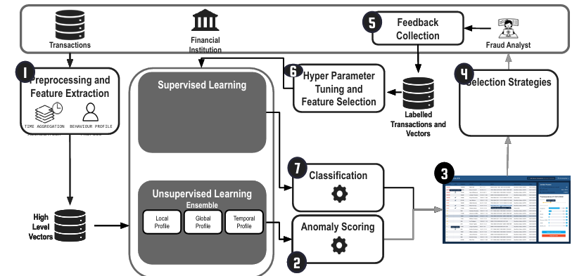
To make a system strong, we try to exploit both methods combined with the expert-based, having a complex system that can be divided in various parts, each one responsible for a specific aspect of fraud. The exact order of adopting the different techniques depend on the characteristics of the type of fraud.

To summarize, the main challenges of developing fraud-detection models are:
- Dynamic nature of fraud
Fraudsters adapt their approaches to commit frauds without being exposed and develop advanced strategies to cover their tracks
- Good detection power
Detect fraud as accurately as possible, low false negative rate (i.e., missed frauds), especially involving enormous amounts and low false alarm rate, to avoid harassing good customers and prevent accounts or transactions to be blocked unnecessarily.
- Skweness of the data
Plenty of historical examples of non-fraudulent cases, but limited number of fraudulent. This might cause an analytical technique to experience difficulties in learning an accurate model.
- Operational efficienty
Limited amount of time available to reach a decision and let a transaction pass or not, it should be a real time interaction. The information or the variables used by the model should not take too long to be gathered or calculated.
- Big data management
Ability to deal with massive volumes of data.
Graph/Network analysis extends the abilities of the fraud-detection system by learning and detecting characteristics of fraudulent behaviours in a network of linked entities. Including an extra source of information in the analysis, being the relationships between entities, it contributes to uncover patterns indicating fraud.
FRAUD MANAGEMENT CYCLE
Composed by all the steps previously described:
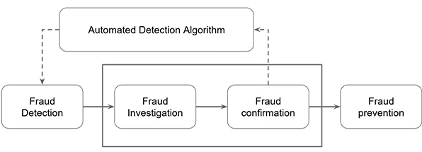

- FRAUD DETECTION Applying detection models on new, unseen observations and assigning a fraud risk to every observation.
- FRAUD INVESTIGATION A human expert is often required to investigate suspicious, flagged cases given the involved subtlety and complexity.
FRAUD CONFIRMATION Determining true fraud label, involving field researchers when needed.
- FRAUD PREVENTION Preventing fraud to be committed in the future.
- AUTOMATED DETECTION ALGORITHM/Feedback Loop: Newly detected cases should be added to the database of historical fraud cases, used to learn or induce the detection model.
Remember that frauds are dynamic phenomenon, hence model needs to be updated regularly. But a regular update of the model is not easy to implement: it is a huge task in terms of money, time, management (for example, by the time the system is updated, the “virus” is already changed). How to decide when and how to update the system? What is the required frequency of retraining or updating?
The frequency of retraining or updating the detection model depends on several factors such as:
- volatility of the fraud behaviour.
- detection power of the current model.
- amount of (similar) confirmed cases already available in the database.
- rate at which new cases are being confirmed.
- required effort to retrain the model.
A ML technique that can come in support in some contexts is Reinforcement Learning, in which models are continuously updated by learning from the newest observations.
FRAUD ANALYTICAL PROCESS
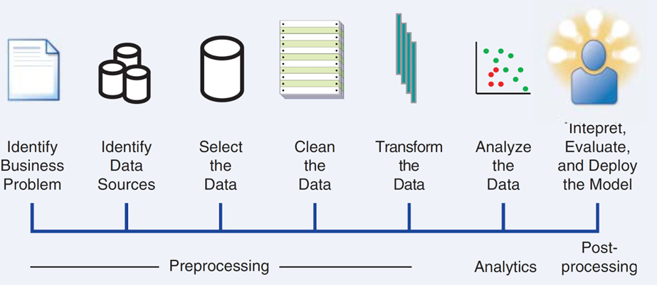
Iterative Process
Identify problem, identify data sources and select relevant data, clean and transform data so that they can be used in the context I am working on, data analysis and interpretation, end with a model deployed.

Possible Analysis Output
- Trivial fraudulent patterns Validation of the model
- Unknown patterns Provide added insight and detection power.
Once the analytical model has been properly validated and approved, it can be put into production.

Additional Consideration
- Since the model will be used by non-IT customers, it is important to represent it in a user-friendly way.
- The model has to be integrated in a full chain of an already working application.
- Monitor and test the model, test it so that it is sure it is continuously updated and useful.

In general, we should remind those key characteristics of successful fraud analytics models and what financial institutions look at when buying them:
- Statistical accuracy
Detection power and correctness of the statistical model in flagging suspicious cases. Different Metrics We need to make sure that the model generalizes well and is not overfitted to the historical data set.
- Interpretability
When a deeper understanding of the detected frauds is required, a fraud-detection model must be interpretable. Model’s interpretability depends on the technique used, that are classified as Open-box models, that allow to understand the underlying reasons why the model signals a case to be suspicious, and Closed-box models, built to be complex and non-interpretable.
- Operational efficiency
Time and effort required to collect and preprocess the data, evaluate the model, monitor and test the model and to evaluate whether a case is suspicious or not.
When cases need to be evaluated in real time, operational efficiency is crucial and is a main concern during model performance assessment.
- Economical cost
Developing and implementing a fraud-detection model involves a significant cost for many operations, such as gather, preprocess, and analyse the data, put the resulting analytical models into production, software, human, and computing resources and external data to enrich the available in-house data.
- Regulatory compliance
Depending on the context there may be internal or organization-specific and external regulation that applies to the development and application of a model. A fraud-detection model should be in line and comply with all applicable regulation and legislation.
CHAPTER 4: MACHINE LEARNING FOR FRAUD DETECTION
data preprocessing task
When talking about data, common sense makes think that “the more is the best”, but machine learning theory teaches overfitting, the model will start to completely be rigid to a certain context, unable to learn new information. Another problem with overfitting is including “dirty data” collected by “non computer engineers”. Data-filtering mechanisms must be applied to clean up and reduce the data. Even the slightest mistake can make the data unusable. We start by classifying the types of data as:
- Continuous Data elements defined on a limited/unlimited interval (example: amount of transactions).
- Categorical Data elements that can only take on a limited set of values. In particular, nominal data if they are taken with no meaningful ordering, ordinal data if there is a meaningful ordering or binary data, which can take only two values.
SAMPLING
Take a subset of historical data to build an analytical model. Again, we do not analyse the full set of data to avoid overfitting, not include old, “invalid” data. Instead, having less and more recent, precise data is better for the model to build for a specific context. In fact, the subset needs to be representative for the future entities. So, it is crucial to choose the optimal time window.
To sum up, it is necessary to find a correct trade-off between the amount of data and their time representativity. Even from the subset, we need to extract an “average period” that will have to be as representative as possible of the target population. By doing so, we are introducing sampling bias, that should be avoided even if it is not straightforward. Two extreme cases:
- Build a model for each period to model. More precise but higher complexity
- Build a model that averages all the periods. Reduced costs but too generic
Stratified Sampling: A sample is taken according to predefined strata. In fraud detection context, data sets are very skew. We need to perform stratification according to the target fraud indicator, hence sample will contain the same percentages of (non-) fraudulent transactions as in the original data. Another kind of stratification is working on predictor variables, thus resembling the real product transaction distribution.
Even choosing the correct sample in time, we need to ensure it reflects the original distribution of the original data.
VISUAL DATA EXPLORATION
The first step for analysing the collected data for our task is to group them in a plot/graph as commonly made in lots of contexts (pie charts, histograms…). By just observing the graphic representations, without even applying any model analysis, we can immediately observe some behaviours and assumptions we can start to work with
Exploratory Statistical Analysis
Move to inspect the collected data with a more critical, statistical point of view to, if possible, detect a common pattern.
Two complementary approaches can be applied in parallel to observe different patterns:
- Basic Descriptive Statistics Basic insights (mean and median, mode, standard deviation and its variation, percentile values: complementary information w.r.t. the distribution and the median value)
- Specific Descriptive Statistics Symmetry or asymmetry of a distribution (skewness, peakedness or flatness of a distribution). They can be assessed easier by inspecting visual plots; in general, they are harder to interpret and more analysis are needed to give the a meaning.
Missing Values
A crucial limitation that we must deal with. Data can be partially/totally missing because of various reasons:
- They can be unusable, for example because of privacy constraint
- They can be undisclosed
- Simply, error during merging source
How to manage this limitation?
Some analytical techniques can deal directly with missing values. In general, when this cannot happen, we need some additional preprocessing:
- Replace the missing value with a known value
- Delete observations or variables with lots of missing values. This assumes that information is missing at random and has no meaningful interpretation and/or relationship to the target
- Keep as “missing” can be meaningful. DELETE/KEEP decision can be made only after we were able to analyse data and decide if they are related to the target class we are dealing with
- Statistically test whether missing information is related to the target variable or not. If yes, we can adopt the keep strategy and make a special category for it. If not, one can, depending on the number of observations available, decide to either delete or replace.
Outliers: extreme observations that are very dissimilar to the rest of the population. Some data might be incorrect semantically or invalid for our context (like analysing salary of a high school professor and the prime minister). Outliers can be univariate (outlying on one dimension) or multivariate (outlying in multiple dimensions).

Univariate Outlier Detection and Treatment Minimum and maximum values for each of the data elements. They can be detected by visual representations such as graphical tools, histograms, box Plot, Z-scores
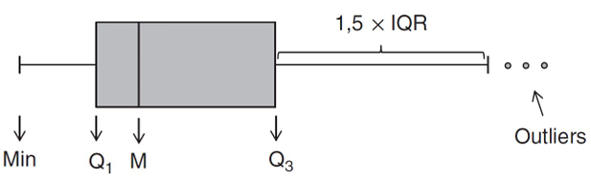
A box plot represents three key quartiles of the data:
- the first quartile (25 percent of the observations have a lower value)
- the median (50 percent of the observations have a lower value)
- the third quartile (75 percent of the observations have a lower value).
This representation helps in reporting that the valeusa re condensed in a specific region distribution with a certain median M and define a criterion to decide what is “normal” and what “outlier”

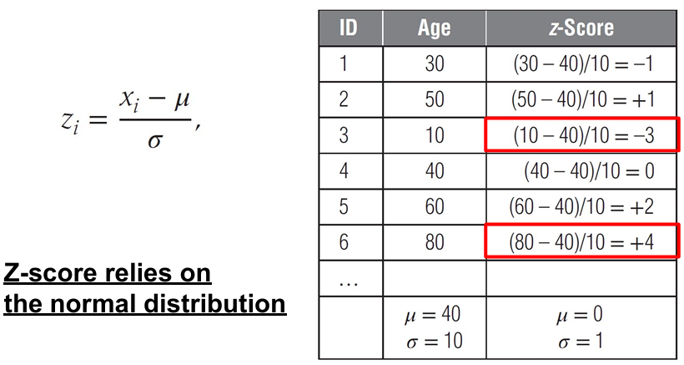
Z-scores
Measures how many standard deviations an observation lies away from the mean

Valid detections for multivariate scenarios are:
- Fitting regression lines and inspecting observations with large errors (using, e.g. residual plots)
- Clustering or calculating the Mahalanobis distance.
Independently from the method, we have to decide what to do with outliers:
- Invalid observations, one could treat the outlier as a missing value.
- Valid observations: Preprocess and transform the data in a way that it doesn’t impact the output. For example, impose both a lower and upper limit on a variable and any values below/above are brought back to these limits
Expert-based Outlier Detection
Not all invalid values are outlying and may go unnoticed if not explicitly looked into. After our analysis, if we do not decide what to do, we can ask to experts, construct a set of rules formulated based on their knowledge, which is applied to the data to check and alert for issues (relations that exist between the different variables; Constraints that apply to the combination of variable values).
Discussion on preprocessing
Handling valid outliers in the data set using the treatment techniques: impair the ability of unsupervised learning techniques analytics in detecting frauds. Be extremely careful in treating valid outliers when applying unsupervised learning techniques to build a fraud detection model. Handling invalid outliers: they can be treated as missing values preferably by including an indicator that the value was missing.
Standardizing Data To a similar range. Examples: Eligible (0/1); Income (Netween 0 and $1,000,000)
- Min/Max standardization, whereby newmax and newmin are the newly imposed maximum and minimum (e.g., 1 and 0)
- Z-score standardization; Calculate the z-scores assuming a normal distribution
- Decimal scaling putting all data to the same scale and have a representative distribution and relation between all data
Categorization
Sometimes we need to transform data so that they are of the same type and are interpreted in the same way. For categorical variables, it is needed to reduce the number of categories. (E.g., IBAN, IP)
Basic methods:
- Equal interval binning bins with the same range
- Equal frequency binning bins with the same number of observations
- Chi-squared analysis
For continuous vaqriables, by categorizing the variable into ranges, nonmonotonicity can be taken into account.
Variable Selection
Many analytical models start with lots of variables, of which typically few actually contribute to the prediction of the target variable. How to find and choose them?
Filters Allow a quick screening of which variables should be retained for further analysis. Measure univariate correlations between each variable and the target. Filters allow reduction in the number of dimensions of the data set early in the analysis. The main problem is that they work univariately and do not consider correlation between the dimensions individually.
Principal Components Analysis A method that makes the data transform in a set a feature that can be related to the original ones and can be used for my analysis. It tries to reduce the dimensionality of data by forming new variables that are not correlated and linear combination of the original variables. These new variables describe the main components or dimensions that are present in the original data set. Max number of new variables (i.e., principal components) = number of original variables.
- Explain all the information (variance) in the original data set, the full set of principal components is needed
- The variance contained in the original variables can be summarized by a limited number of principal components
- Some of these account for a very small fraction of variance of the original variables. Therefore, they can be left out.
- Reduced dimensionality in the data set

Drawbacks: Replacing the original variables with a (reduced) set of uncorrelated principal components comes at a price: reduced interpretability. They are a weighted linear combination of the original variables. When interpretability is no concern, PCA is a powerful data reduction tool that will yield a better model in terms of stability as well as predictive performance.
UNSUPERVISED LEARNING FOR FRAUD DETECTION
Aims to find anomalous behaviour w.r.t. to the norm. It can be defined as:
- Behaviour of the average customer at a certain time
- Average behaviour during a certain time period
Another definition consists of identifying anything that is anomalous, even if it is not an actual fraud. In that way we do not make our detector depend on past activities. Unsupervised learning come to be relevant in environments where:
- Organizations are starting fraud detection
- There is no labeled historical data set available, so supervised learning is unapplicable
- Fraudsters are continuously adapting their strategies.
Main disadvantage is that we have to define the “average behaviour” (norm). Also, boundaries between norm and outliers is not clear-cut and fraudsters can try to blend into norm by behaving as “normal”. In that case, anomalies do not necessarily represent frauds and it is important to define when they do.
Graphical otulier detection procedures can be helpful to make some statistic analysis to define a certain “mean behaviour”, biases and similar
Ideal tools to explore the data and get preliminary insights are:
- One-dimensional outliers (histogram or box plot)
- Two-(three) dimensional outliers (scatter plot)
Their disadvantages are:
- Less formal and only limited to a few dimensions
- Require active involvement of the final user
- For a large dimensional data set, is cumbersome.
When comes to Statistical Outlier Detection we can work with:
- Z-Score as described before
- Fit a distribution, or a mixture of distributions. Here, the outliers are observations with small values for the probability density function
- Break Point Analysis
Also known as an intra-account fraud detection method, the idea is to define as break points the sudden change in an account behaviour.
- Define a fixed time window
- Split it into “old/new” part
- Compare them
- Peer Group Analysis
Here, we perform inter-account analysis. Peer groups are group of accounts that behave similarly to the target account. When the behavior of the target account deviates substantially from its peers, an anomaly can be signaled.
- The peer group of a particular account is identified, that can be done in various ways (prior business knowledge; Statistically; computing the number of peers as if it is too small (too local) we have sensitivity to noise and if too large (too global) insensitive to local important irregularities
- Target account behavior is contrasted with its peers by working with Statistical test ot distance metric
When to use peergroup and when breakpoit analysis?
Break point) When we cannot define enough peers; more precise for higher data informations
Peer group) if we are able to define peers with specific pattterns, and since all the peers behave the same no fraud are detected as they will behave as norm. But it is impossible to find and update all the peers at the same time and in real time
Clustering
A procedure that consists in splitting up a set of observations into segments (i.e., clusters) that maximize
- The homogeneity within a cluste
- The heterogeneity among separated clusters
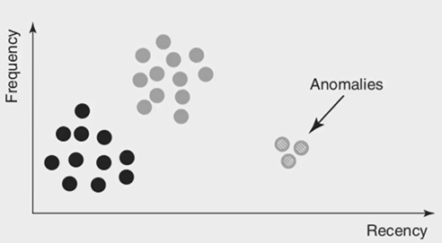
It is important to corretly select the data for clustering (Structured/Unstructured information). In particular, for unstructured information we look for as much data as possible to gain as much case sas possible, and it is generally avoided excessive amounts of correlated data by applying feature selection methods.
In the context of Fraud Detection, we aim to “Group anomalies into small, sparse clusters, based on similarity”
A distance metric is needed to quantify similarity. Various distance metrics have been introduced for both continuous and categorical data.
Continuous Variables: Euclidean metric, Pearson correlation or cosine measure
Categorical (Binary) variables: Simple Matching Coefficient (SMC) = calculates the number of identical matches between the variable values (equally important); Jaccard index = measures the similarity between both claims across those red flags that were raised at least once.
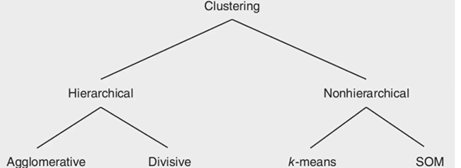
Hierarchical:
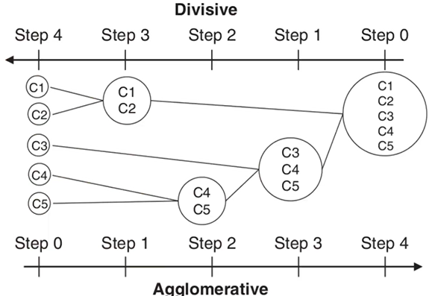
Depending on which version, the idea is to split/unite each part in/from various subsets of clusters. In general, 1 or 2 steps of divisions/union should be enough for the purposes
In order to decide on the optimal number of clusters, various apporaches can be taken:
- Dendrogram tree-like diagram that records the sequences of merges. vertical (or horizontal) scale gives the distance between two clusters amalgamated. Then, cut the dendrogram at the desired level to find the optimal clustering
- Screen plot plot of the distance at which clusters are merge. The elbow point indicates the optimal clustering
Hierarchical clustering do not require to priorly define the number of clusters but it do not scale very well to large data sets, and the interpretation of the clusters is often subjective.
k-Means:
- Select k observations as initial cluster centroids (seeds).
- Assign each observation to the cluster that has the closest centroid (e.g., Euclidean distance).
- When all observations have been assigned, recalculate the positions of the k centroids (mean)
- Repeat until the cluster centroids no longer change or a fixed number of iterations is reached

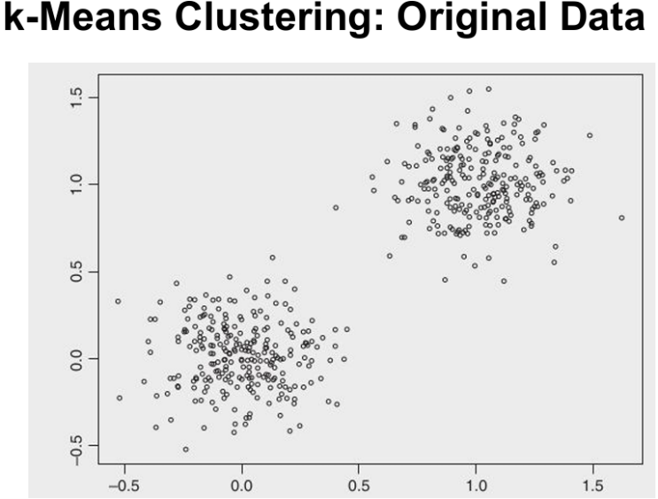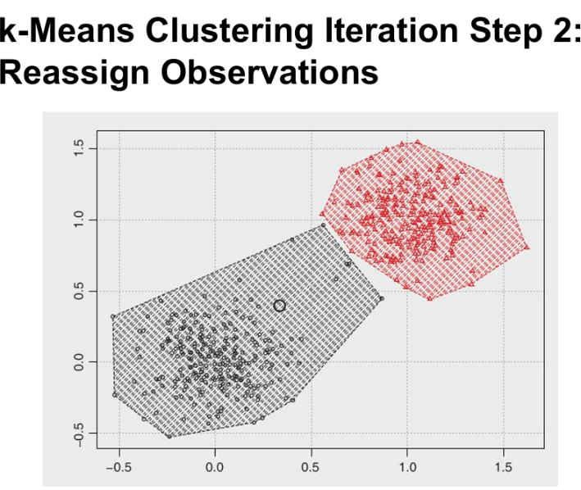
This approach has various limitations:
- The number of clusters k needs to be specified before the start of the analysis. Various options can be followed, as expert based input, result of another (e.g., hierarchical) clustering procedure, tryout different seeds to verify the stability of the clustering solution
- k-means is sensitive to outliers, especially relevant in a fraud detection setting
- A more robust alternative is to use the median instead (k-medoid clustering)
- In case of categorical variables, the mode can be used (k-mode clustering).
Lastly, i have to find a way to separate, evaluate and interprete clustering solutions
STATISTIAL PESPECTIVE: The Sum of Squared Errors (SSE) 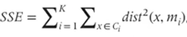, where K represents the number of clusters and m_i the centroid (e.g., mean) of cluster i. When comparing two clustering solutions, the one with the lowest SSE can then be chosen.
SELF-ORGANIZING MAOS SOM:
Allow users to visualize and cluster high-dimensional data on a low-dimensional grid of neural network. So, feedforward neural network with an input and an output layer.
Each input is connected to all neurons in the output layer with weights w = [w₁ , ... , w_{N} ]. All weights are randomly initialized. When a training vector x is presented, the weight vector of each neuron c is compared with x:
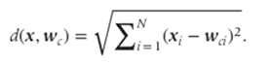
The neuron that is most similar to x in Euclidean sense is called the Best Matching Unit (BMU). weight vector of the BMU and its neighbors in the grid are then adapted using the following learning rule:
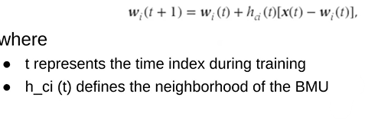

h__{ci}(t) is a nonincreasing function of the time and the distance from the BMU. The decreasing learning rate and radius will give a stable map after a certain amount of training; the neurons will then move more and more toward the input observations and interesting segments will emerge. Training is stopped either when the BMUs remain stable or after a fixed number of iterations (e.g., 500 times the number of SOM neurons)

SOMs can be visualized by means of a U-matrix or component plane:
- U (unified distance) - matrix superimposes a height Z dimension on top of each neuron visualizing the average distance between the neuron and its neighbors
- A component plane visualizes the weights between each specific input variable and its output neurons. It provides a visual overview of the relative contribution of each input attribute to the output neurons
In conclusion, SOMs are a very handy tool for clustering high-dimensional data sets because of the visualization facilities. Since there is no objective function to minimize, it is harder to compare various SOM solutions against each other. Experimental evaluation and expert interpretation is needed to decide on the optimal size of the SOM. Unlike k-means clustering, a SOM does not force the number of clusters to be equal to the number of output neurons.
SUPERVISED LEARNING FOR FRAUD DETECTION
We have to intoruduce it by underlying that it relies on historical data. The model learns to identify known patterns, such as frauds, and how to distinguish from a normal and a fraudolent label. Based on the provided samples, it classifies new, unseen istances. The aim is to build an analytical model predicting a target measure of interest. The target is used to steer the learning process; label indicates whether a transaction was fraudulent classify a new instance as fraudulent or not.
The target fraud indicator is usually hard to obtain and determine. It is rarely possible to confirm with certainty whether a transaction is fraudolent, and also generally obtain fraudolents label is hard since exposing real case might be an image damage. Also, human and system errors can make labels nose or inaccurate.
Key challenge: avoiding overfitting to noisy or mislabeled data to ensure model reliability.
Supervised Learning problems can be described in various types:
- Regression continuous target variable (not a binary resulta s 0/1, T/F), predict numeric values over a defined or open range. Target variables are then compared with real data.
- Classification categorical target variable. Predict membership in a predefined class. The simplest, didactical version is binary classification, with two possible outcomes. In general, we talk about multiclass classification

(Review of Linear/Logistic Regression and Classification from ML classes)
Variable space selection can be navigated in three possible ways:
- Forward regression: starts from the empty model and always adds variables
- Backward regression: starts from the full model and always removes variables
- Stepwise regression: mix between the tw
To perform variable selection, we assign to each one a statistical significance. A good parameter is the p-value, that is the probability of getting a more extreme value than the observed. As low as the p-value is, as high the variable is significant. Next, we consider variable interpetability, as the increase/decrease of the outcome (based on the positive/negative sign of the regression coefficient); the operational efficiency (cost/effort to collect, clean and use the variable) and legal issues regarding certaint features.

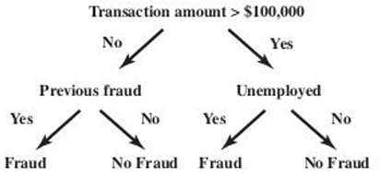
Another method is the decision trees, one of the most useful and most common in use. The structure distinguish:
- Root node testing condition
- Internal nodes split in branches based on outcomes
- Leaf nodes class labeling

Some considerations involve the testing conditions, which feature to split and what the threshold is when to stop adding nodes, assign a class for each leaf.
In order to answer the splitting decision, one must define the concept of impurity or chaos. In particular, Minimal impurity occurs when all customers are either good or bad and Maximal impurity occurs when one has the same number of good and bad customers.Impurity can be measured by means of various formulas, like entropy or gini, and the goal is to minimize the outcome of the computation. Candidate splits are so evaluated on how much they reduce impurity over information gain.
Stopping Decision is, as well, to address in order to avoid getting literallly one leaf node per observation, becoming too complex and fails to correctly model the trend in the data and it will generalize poorly to new unseen data.

The error on the training sample keeps on decreasing as the splits become more and more specific and tailored towards it. On the validation sample, the error will initially decrease, which indicates that the tree splits generalize well. At some point the error will increase since the splits become too specific for the training sample as the tree starts to memorize it. Where the validation set curve reaches its minimum, the procedure should be stopped, as otherwise overfitting will occur.

Using Decision Trees in Fraud Analytics:
- Variable selection variables that occur at the top of the tree are more predictive
- Measure the predictive strength of a variable calculate the Gain of a characteristic to gauge its predictive power
- Analytical fraud model to be used directly into the business environment
- Interpretability
Advantages:
- White-box (Intepretable) model with a clear explanation
- Operationally efficient: fast to train and to apply to large datasets
- Powerful decision boundaries non linear relationships are caught better than logistic regression
- Non parametric: no assumpitions about data distribution
Disadvantages:
- Highly dependent on the sample that was used for tree construction. A small variation in the underlying sample might yield a totally different tree.

White-box, supervised techniques can be used to explain the solution of (unsupervised) black-box models
(Review of Neural Networks from ML classes)
In the fraud analytics conext, complex patterns rarely occur. Generally, it suffices to use a neural networks with one hidden layer.
The optimization is more complex as it requires iterative algorithms that optimize a cost-function:
- Continuous target variable Mean Squared Error (MSE) cost function
- Binary target variable Maximum Likelihood cost function The procedure starts from a set of random weights, which are then iteratively adjusted to the patterns in the data using an optimization algorithm (e.g., Back propagation learning, Conjugate gradient).
Key issue: the curvature of the objective function is not convex and may be multimodal. The error function can thus have multiple local minima but typically only one global minimum. If the starting weights are chosen in a suboptimal way, one may get stuck in a local minimum.
Neural Network Weights Learning Preliminary Training:
- Try out different starting weights
- Start the optimization procedure for a few steps
- Continue with the best intermediate solution
- Stopping Criterion The optimization procedure then continues until:
- the error function shows no further progress
- the weights stop changing substantially
- after a fixed number of optimization steps (Epochs).
Hidden Neurons Number Represents nonlinearity in data. They should be carefully tuned:
- Split the data into a training, validation, and test set.
- Vary the number of hidden neurons
- Train a neural network on the training set
- Measure the performance on the validation set.
- Choose the number of hidden neurons with optimal validation set performance.
- Measure the performance on the independent test set.
Overfitting Problem Neural networks can model very complex patterns and decision boundaries in the data, including the noise in the training data. Two options can be followed
- Training set estimate the weights; Validation set independent data set used to decide when to stop training and avoid this overfitting.
- Weight regularization: keep weights small in absolute sense to avoid fitting the noise in the data; Add a weight size term to the objective function of the neural network
Opening the Neural Network Black Box
Black-box = relate inputs to outputs in a mathematically complex and nontransparent way.
It is applied as high-performance analytical tools in settings where interpretability is not a key concern. In application areas where insight into the fraud behavior is important, one needs to be careful with NNs. Next, we describe various metodologies we can apply:
- Variable selection
Select variables that actively contribute to the NN output.
- In linear and logistic regression
- inspecting the p-values In neural networks
- no p-values.
Hinton diagram
Visualizes the weights between the inputs and the hidden neurons as squares:
- Size of the square is proportional to the size of the weight
- Color of the square represents the sign of the weight (e.g., black=negative weight and white=positive weight).
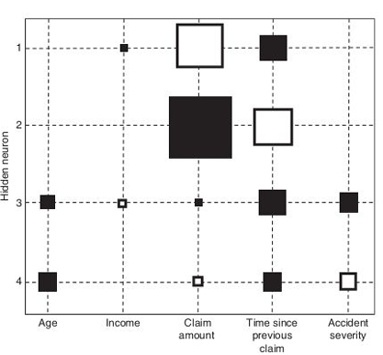
  - Inspect the Hinton diagram and remove the variable whose weights are closest to zero.
  - Reestimate the neural network with the variable removed. To speed up the convergence, it could be beneficial to start from the previous weights.
  - Continue with step 1 until a stopping criterion is met.

The stopping criterion could be a decrease of predictive performance or a fixed number of steps

(Performance-driven) Selection: Backward Variable Selection
- Build a neural network with all N variables.
- Remove each variable in turn and reestimate the network. This will give N networks each having N – 1 variables
- Remove the variable whose absence gives the best performing network (e.g., in terms of misclassification error, mean squared error).
- Repeat this procedure until the performance decreases significantly

In conclusion, variable selection allows users to understand which variables are important and which not. On the other hand, it does not offer a clear insight into its internal workings. We don’t know not which are classified as fraudolent. The relationship between the inputs and the output remains nonlinear and complex. Sampling can be used to make the procedure less resource intensive and more efficient
- Rule extraction
Rule extraction procedure aims to extract if-then classification rules. It can be done in two possible approaches:
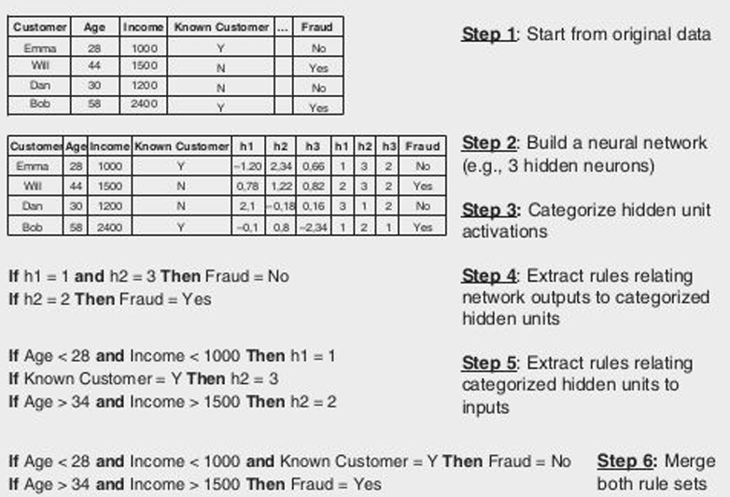
- Decompositional technique: try to analyse the inner working of the neuarl network (weights) and assign rules to the functioning of the weights. Extract human-readable decision rules from a trained NN (considered as white box) used for fraud detection

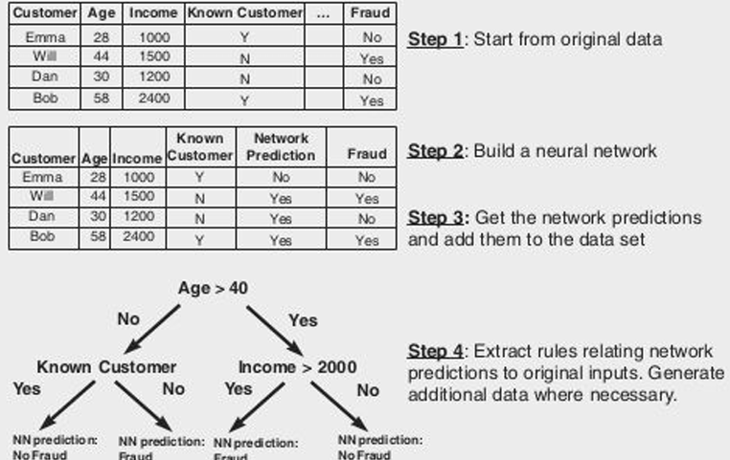
- Pedagogical technique: consider the neural network as a black box and use the neural network predictions as input to a white-box analytical technique such as decision trees. This second approach can essentially be used with any underlying algorithm

Rule sets must be evaluated in terms of accuracy, conciseness and fidelity, that measures to what extent the extracted rule set succeeds in mimicking the neural network 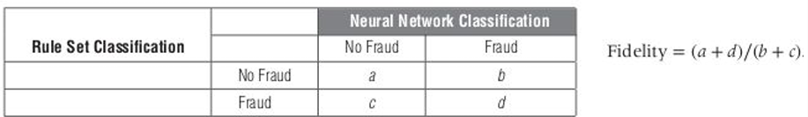
Eventually, benchmark the extracted rules with a tree built directly on the original data.

- Two-stage models
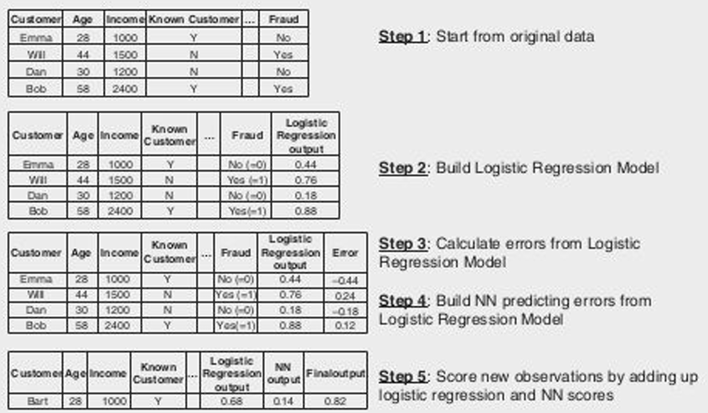
The previous metodologies do not actually describe how the NN works, it just try to mimic the functioning and try to build an alternative model to perform the operations we want to interpret. This third approach works as follow:
- Estimate an easy-to-understand model first (e.g., linear regression, logistic regression), providing the interpretability part.
- Use a neural network to predict the errors made by the simple model using the same set of predictors. a. performance benefit of using a nonlinear model.
Both models are then combined in an additive way

(Review of SVMs from ML classes)
Opening the SVM Black Box: Transparency
Rule extraction approaches SVM can be treated as NN, where hidden layers uses kernel activation functions, and corresponds to the number of support vectors, and the final output uses a linear activation function.
Pedagogical approach can be easily combined with SVMs since considers the underlying model as a black box. In particular, SVM is first used to construct a data set with SVM predictions for each of the observations. This data set is then given to a decision tree algorithm to build a decision tree. Finally, additional training set observations can be generated to facilitate the tree construction process.
Two-stage models can be used to provide more comprehensibility. For example, a simple model (e.g., linear or logistic regression) is estimated first, followed by an SVM to correct the errors
ENSEMBLE METHODS
Ensemble methods are methods that try to combine multiple analytical model aiming to exploit the advantage of all of them and mitigate their weaknesses
They are commonly used with decision trees, and the main methodologies are:
- Bagging (Bootstrap aggregating)
Goal: reduce variance and improve stability of models by combining predictions from multiple classifiers trained on different data samples.
- Sample with replacements
- Generate B bootstrap samples from the original datased
- Train B models, one per bootstrap sampe
By using regression, we use the average prediction across models; while classification uses
majority vote across models. Number of bootstraps can be fixed or optimized via validation.
What can be impressing is that bagging is well suited when the base model is unstable, when
small changes in data cause large changes in predictions. It doesn’t help when the starting
model is already stable and robus to data perturbations
- Boosting
Goal: Build a strong learner by combining multiple weak models trained on weighted data.
- Initialize with equal weights for all training examples
- Update iteravitely, increasing weights for misclassified samples and focusing on “hard” cases, sifficult observation, more carefully in subsequent rounds
- Combine all models in a weighted ensemble
Final model is a weighted combination of all the individual models. Number of bootstraps can be set manually or optimized via validation. It is simple to implement and many ML libraries support it, but it may overfit to difficult examples in data. Especially in the context of fraud detection, where labels are often uncertain, it is a critical issue to consider.
- Random forests
Goal: build a forest of decision trees randomizing and bootstrapping to improve accuracy and robustness
  - Start with a dataset of n observations and N input features
  - Choose m features to consider at each split
  - For T iterations, take a bootstrap sample of the data and build a decision tree
- At each split, select m random features; choose the best split among them and grow the tree fully, without pruning
Overfitting is reduced, hidh-dimentional data are well handled and it works very well for both regression and classification. Their are limited by their “black-box nature”, as the complexity of many combined trees make the model interpretation hard. What to remember:
- Diversity throught bootstrapping Each tree is trained on a different random sample
- Random feature selection at each split Increases tree diversity and reduces correlations between trees
- Strong individual models Each decision tree contibutes meaningfully to the final ensemble
Diversity of base classifiers leads to a robust ensemble that outperforms individual models in
terms of accuracy and generalization

POST-PROCESSING: EVALUATING A FRAUD DETECTION MODEL
When evaluating predictive models, two key decisions need to be made. A first decision concerns the data set split up. A second decision concerns the performance metrics.
The decision on how to split up the data set for performance measurement depends on its size. For large data sets, data can be split up in a 70% for training dataset to build the model and 30% to Test dataset to calculate its performance. This has to be a strict separation, meaning that no observation that was used for training, can be used for testing.
In case of decision trees or neural networks, the validation sample is a distinguished one, and it is used during model development. In that case, split is made as 40% for training, 30% validation and 30% for test sample. Stratified split-up ensures that fraudsters/nonfraudsters are equally distributed amongst the various samples.
For small data sets, special schemes need to be adopted. Some of them are:
- Cross-validation the data is split into K folds. An analytical model is then trained on K – 1 training folds and tested on the remaining fold. The operation is repeated for all possible validation folds, resulting in K performance estimates, which are eventually averaged. Make sure that no fraud/fraud odds are the same in each fold
- Leave-one-out cross-validation every observation is left out in turn and a model is estimated on the remaining K – 1 observations. This gives K analytical models in total.
Model Selection
Cross-validation gives multiple models. Depending on what to perform, we have to carefully choose among them. Some common selections are:
- All models collaborate in an ensemble setup by using a (weighted) voting procedure
- Leave one out cross-validation and pick one of the models at random. Since the models differ up to one observation only, they will be quite similar anyway
- Build one final model on all observations but report the performance coming out of the cross-validation procedure as the best independent estimate.
Performance Metrics
Classification accuracy is the percentage of correctly classified observations: (TP + TN) / (TP+FP+FN+TN)
Classification error is the complement thereof, also referred to as the misclassification rate: (FP + FN) / (TP+FP+FN+TN)
Sensitivity, recall or hit rate measures how many of the fraudsters are correctly labeled as a fraudster: TP / (TP+FN)
Specificity looks at how many of the nonfraudsters are correctly labeled by the model as nonfraudster: TN / (FP+TN)
Precision indicates how many of the predicted fraudsters are actually Fraudsters: TP / (TP+FP)

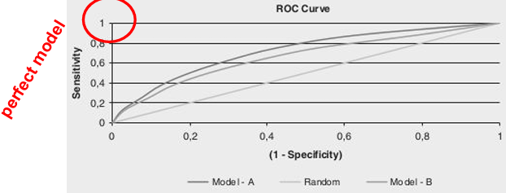
All these classification measures depend on the cut-off. For a cut-off of 0 (1), the classification accuracy becomes 40% (60%); the error 60% (40%); the sensitivity 100% (0%); the specificity 0% (100%); the precision 40% (0%) ● the F-measure 0.57% (0%). Those relations can be reported on the ROC (Receiver Operating Characteristic) Curve
A problem arises if the curves intersec. AUC (Area Under ROC Curve) provides a simple figure-of-merit for the performance:
- The higher the AUC, the better the performance
- Bounded between 0 and 1, so it can be interpreted as the probability that a randomly chosen fraudster gets a higher score than a randomly chosen nonfraudster A good classifier should have an ROC above the diagonal and AUC bigger than 50%.
Other performances metrics
Interpretability White-box: Linear and logistic regression, decision trees. Black-box: Neural networks, SVMs, and ensemble methods.
Justifiability Verifies to what extent the relationships modeled are in line with expectations verifying the univariate impact of a variable on the model’s output.
Operational efficiency ease with which one can implement, use, and monitor the final model to be able to quickly evaluate the fraud model. Linear and rule based models are easy to implement
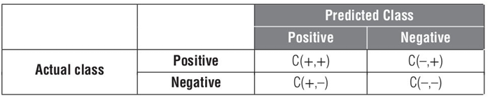
Cost-sensitive Learning Assign higher misclassification costs to the miority class. Usually C(+, +) = C(–, –) = 0, and C(–, +) > C(+, –). Minimizing the misclassification cost during classifier learning.

Fraud-detection data sets often have a very skew target class distribution frauds are ≤ 1%. This creates problems for the analytical techniques, flooded by nonfraudulent observations and thus tend toward classifying every observation as nonfraudulent. It is recommended to increase the number of fraudulent observations or their weight, so that the analytical techniques can pay better attention to them.
Increase the number (and variability) of frauds is by:
  - Increasing the time horizon for prediction
  - Sampling every frauds twice (or more) We predict fraud with a one-year forward-looking time horizon using information from a one year backward looking time horizon by shifting the observation point earlier or later, the same fraudulent observation can be sampled twice. The variables collected will be similar but not perfectly the same, since they are measured on a different time frame.
Finding the optimal number is subject to a trial-and-error exercise depending on the skewness of the target

Oversampling
Replicate frauds two or more times so as to make the distribution less skew.
Undersampling
Remove nonfrauds two or more times so as to make the distribution less skew, based on business experience whereby obviously legitimate observations are removed.

Under- and oversampling can also be combined, as Undersampling usually results in better classifiers than oversampling. They should be conducted on the training data and not on the test data to give an unbiased view on model performance.
Working toward a balanced sample with the same number of fraudsters and nonfraudsters, it may biases the performances. It is recommended to stay as close as possible to the original class distribution to avoid unnecessary bias.

Practical approach to determine the optimal class distribution
- An analytical model is built on the original data set with the skew class distribution (e.g., 95%/5%)
- The AUC of this model is recorded (possibly on an independent validation data set).
- Over- or undersampling is used to change the class distribution by 5 percent (e.g., 90%/10%).
- The AUC of the model is recorded.
- Subsequent models are built on samples of 85%/15%, 80%/20%, 75%/25%, recording their AUC.
- Once the AUC starts to stagnate (or drop), the procedure stops and the optimal odds ratio has been found
Synthetic Minority Oversampling Technique (SMOTE)
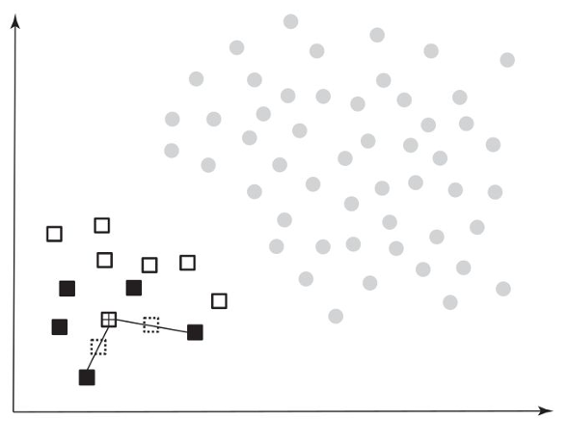
Rather than replicating the minority observations, SMOTE works by creating synthetic observations based on the existing minority observations.
For each minority class observation, it calculates the k nearest neighbors (depending on the amount of oversampling needed, one or more of the k-nearest neighbors are selected to create the synthetic examples).
Then, randomly create two synthetic examples along the line connecting the observation under investigation with the two random nearest neighbors.
SMOTE then combines the synthetic oversampling of the minority class with under-sampling the majority class.
SMOTE usually works better than either under- or oversampling
CHAPTER 5: Introduction to Digital Forensics
Forensics is the application of scientific analysis methods to reconstruct evidence, generally for crime analysis purposes. There are several forensics approaches, like chemistry, dna-analysis etc.
In our context, we are interested in the Digital Forensics, not intended as PC only but for every device that works with digital components (robots, satellites etc.), that is forensics applied to digital data, computer systems, network data etc.
With scientific analysis we are referring to different types of evidence that are analysed and different ways to do it, as each nation has its own laws and, consequently, requires for different approaches. Although we’ll try to be as general as possible, our studies and consideration will tend to base to Italian law.
Careful on the fact that analyser can become witness based on the results of his studies but again based on the country this consideration can vary. In particular, USA models rely on the Daubert standard that states that a witness may testify with his analysis only when all those constraints occur:
- The expert's scientific, technical, or other specialized knowledge will help the trier of fact to understand the evidence or to determine a fact in issue.
- The testimony is based on sufficient facts or data (NOT AN OPINION)
- The testimony is the product of reliable principles and methods; and
- The expert has reliably applied the principles and methods to the facts of the case
Elements of the Daubert standard are:
- Relevance and reliability expert testimony "relevant to the task at hand" and rests "on a reliable foundation"
- Scientific knowledge scientific method/methodology

With “scientific”, we can refer to repeatability (experiments that can practically be performed repeatedly bringing the same results) and falsifiability (“if I can find a logical experiment that can falsify a statement, it is scientific”. So, pay attention that scientific ≠ true/false statements)
Factors to consider when defining something as “scientific”:
- Whether the theory or technique employed by the expert is generally accepted in the scientific community
- Whether it has been subjected to peer review and publication
- Whether it can be and has been tested
- Whether the known or potential rate of error is acceptable
- Whether the research was conducted independent of the litigation or dependent on an intention to provide the proposed testimony
!In Italy, with “prova” (literal translation of “evidence”) we juridically refer to what a judge already has evaluated and considered as evidence. To refer to “evidence” as we are doing, we say “fonte di prova”

Investigation phases consist in 4 main steps:
- Source acquisition
- Evidence identification
- Evaluation
- Presentation
CHAPTER 6: Source acquisition
We start by making an important premises: forensic procedures have been developed with respect to the US laws, but obviously other countries have other laws and ways to approach criminalities. In particular, we make an important example and comparison with the Italian law on how evidence are acquired. Evidence in USA are related to the “chain of custody” (ensure authenticity, integrity and security) and especially admissibility. In fact, in the USA evidence acquired in a violation of law are automatically discarded while in Italy (and almost everywhere in EU) the evidence is based on the evaluation performed by the judge, and it is him who consider admissible or not certain evidence.
In Italy, the standard for inadmissibility is “evidence collected in a violation of laws” (during an illegal search), but we do not have the concept of “chain of custody”.

What probably is the most important concept in this course is that Digital evidence is brittle (=fragile). In other words, if something (a file) is modified there is no way to tell it (=IT IS NOT TAMPER EVIDENT). It is possible to create a perfect fake, reconstruct file with timestamps that can please the creator (for example, “proving” that I was home working at the pc at the same time when actually I was committing a crime).
I need procedures that ensure, as much as it can be possible, that digital evidence sources have been tampered.
Before to move to what this procedure is, it is important to clarify a couple of aspects: in general, having only digital evidence are not enough for having a true/false proof. Secondly, it is needed to ensure, when bringing evidence, legal compliance, ethical behaviour from all parties, detection of errors in good faith and detection of natural decay. Lastly, in Italy an evidence gets discarded only when it is proved it has been tampered.
In general, the chosen approach relies on using hashes, “fingerprint of evidence”, a string that ensures whether a file has been modified (it completely changes when it happens). If the hash of a digital object is recorded at a given step of acquisition, and then constantly checked in further steps, it can ensure on the identity, authenticity and non-tampered state from that step on.
It is important to understand that:
- Hashes are not a dogma: you cannot just say “there is no hash” and dismiss everything. Why is there no hash? Has any other measure been taken? Can we still reconstruct the chain of acquisition?
- Hashes are not magic: computing a hash does not say anything about what happened before the hashing took place.
- To be useful, hashes must be either sealed in writing (e.g. on a signed report), or encrypted to form a digital signature

Typical hardware/software for acquisition
Hardware:
- Removable HD enclosures, connectors with different plugs
- Write blocker
- External disks, USB, firewire, SATA and e-SATA controllers, if possible
Operating system:
- Linux: extensive native file system support + ease of accessing drives and partitions without “touching” (mounting) them

When possible, we want to acquire a bitstream image, that is a bit-to-bit copy (or clone) of the original evidence media (a pendrive, hard disk, cell phone etc.)
Basic procedure of acquisition:
- Basic acquisition of a powered-down system
- Disconnect the media from the original system (if possible, if not possible see ahead for usage of forensic distributions)
- Connect the source media to analysis station, if possible with a write blocker
- Compute the hash of the source
- Copy the source
- Compute the hashes of both source and copy/clone
- Compare the three hashes
- It could be good to compute also MD5 and SHA-1 hashes of the image at least, for redundancy and to be sure it can be compared

Write blockers can be helpful for our context. They are interfaces that connects on 1-side on the drive and outputs tools to use for cloning. THEY CANNOT WRITE ON THE DRIVE, it only ensures that the original drive doesn’t get modified in any way, ensuring data integrity. It clones a disk by acquiring the bitstream image as described before. They can be proven to be strong to ensure data integrity when acquiring sources, but sometimes they face difficulties and turn out to be inefficient. Typical examples are:
- Systems that cannot be shut down, as the write blocker first needs to “disconnect the media from the original system”, ad if it cannot be done acquisition cannot be reliable
- Encrypted files, as a perfect clone is hard to obtain even knowing the key

Challenges: time
Typical hard drive capacity today: approximately 1TB. Typical transfer speeds:
SATA 2 can transfer over 300MB/s (SATA 3 doubles this), but traditional rotational drives reach approx 100MB/s at peak, and average at around 80MB/s.
SSDs can max out the controller
USB transfers can be even slower: 20 to 100 MB/s
This means that for a 1TB drive you can expect to wait several hours to complete a copy (or to run a hash). Some software may automate part of the procedure (e.g. compute the source hash while copying, in parallel)
Challenges: size

Dealing with today’s capacity in storage is complex, in particular for large-scale investigations. Using external media (e.g. USB drives) slows down operations.
NAS (Network Attached Storage) or SAN (Storage Area Network) systems are common in forensic shops.
Sometimes, moving images across a network can be useful; the simplest way to achieve is to setup on a host and run on the acquisition side

Challenges: encryption
There is an increasing use of encryption in regular laptops and PCs. It is already a serious constraint in mobile devices. Even if provided with key, performing acquisition in a repeatable way is challenging
Embedded forensic duplicators are devices where a drive to copy can be attached ad clones it bit-to-bit automatically. With respect to the standard procedures described, some common alternatives can be discussed:
- BOOTING FROM LIVE DISTRIBUTION. It is the case in which we need to work directly on the machine. Examples are some specific Hardware or controllers that cannot be easily “virtualized”, or RAID devices (both for HW and SW, but generally hardware. That is hard to retrieve remotely). In this case, we can live-boot the system under assessments using a Linux distribution targeted to forensic analysis. Ordinary live distros may mount and, once boot, we can use the command lines we already saw to clone the drivers. We are using specific Linux distributions designed specifically for forensic analysis
By exploiting forensic tools (USBs, DVDs etc.) and Linux O.S., we can connect to the machine by using those tools, and thanx to Linux neither the original O.S. will not be involved nor the data will be tampered with, and the cloning process will be performed ensuring valid evidence
- TARGET POWERED ON. Server computers, or more generally computer that need to stay on constantly. It can be ok to turn them off when, for example, needing to “freeze” evidence and prevent any possible modifications on them. In general, the decision in based on why the computer is on if there is a cost on turning it off. Ideally, we work in “volatility order” (what is going to be modified first)
- Dump of memory: if possible, and not costly; hardware tricks to perform the dump are available (firewire)
- Save runtime information (network, process information…)
- Disk acquisition
It could be possible to perform the acquisition without a shutdown; if impossible, pull the plug. Document all activities executed before sealing the evidence
- LIVE NETWORK ANALYSIS. It is not a machine analysis, instead it focuses on a “live” analysis of what is happening, about what the attacker is actually doing and how he behaves. Remember that tools installed on a compromised machine may be unreliable (like rootkit)
New, modern challenges involve Cloud forensics, Mobile forensics and SSD peculiarities.
CHAPTER 7: Evidence identification
This section focuses on analysis (or identification of) toolsets. The ideal O.S. to use is Linux thanks to its extensive native file system support, especially of hot swapping drives and devices, mounting images, etc.
Why not Windows?
- Windows MUST be confined because it tampers with drives and modifies evidence, it has no image handling or hot swapping of drives and no support for non-Windows FS
- Using Linux as host, and Windows as guest, we can work the images with Linux, mounting them read-only and then exporting them via Samba to Windows and Use specific Windows tools
- Not always doable to use Samba: if Windows must see the file system (e.g. file recovery tool or unallocated space analysis) we can mount the image as a read-only loop device under Linux, and/or use the “non-persistent” mode of VMWare

To recall, Scientific means...
- Repeatable Any other expert will be able to perform the same experiment obtaining the same results I obtained
- The experiment Not just a tool input and output, but also the logic (clear instructions)! Result validation, the “expert” must be able to perform the same analysis by hand (at least in theory)
- This means that analysis software needs to be open sourced, and possibly free. That proprietary or “law enforcement only” tools are not really fit for the job
A typical challenge is related to recover deleted data. In many cases, information or data of interest has been (voluntarily or involuntarily) deleted. One of the most typical forensics computer tasks is retrieve them. To understand how, we need a brief recall of how O.S. stores data and what happens when files get deleted. We’ll describe UNIX’s file system (Linux), but almost all of the systems behave the same (File Allocation Table --- Windows etc.)
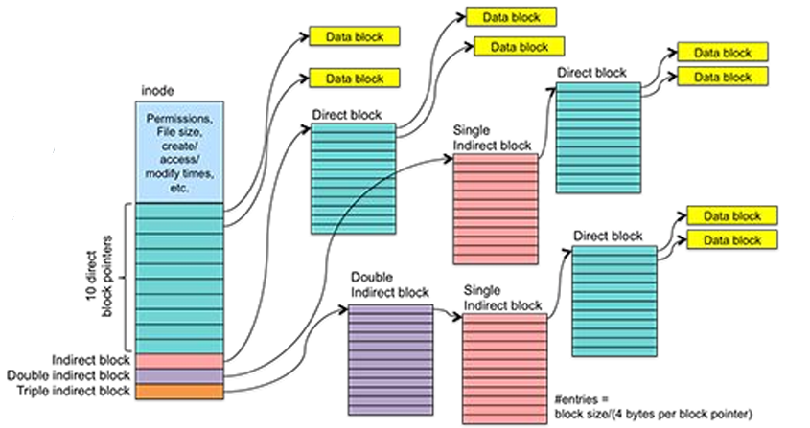
Space in the drive (organized in files and folders) makes usage of indexes
inode is a structure with the file metadata (name, size, paths, creation data etc.) and pointers to where the data is on the drive. Pointers can be to direct to data block or indirect to the data block by means of blocks as shown in the picture
What happens on file deletion? OS is “lazy”, and optimizations cause data persistence and locality. When we delete a file, first the file entry in the FS (File System) is flagged as “non present” (Until here, it can be “undeleted” by simply removing the flag). Up to now, nothing is really deleted and the metadata are simply nonvisible with the standard interface, but they are still in the disk memory. Then, at some random time, the following two things will eventually happen, not in a particular order:
- The FS entry will be removed (when FS structure is rewritten or rebalanced)
- The actual blocks (once) allocated to the file will be overwritten with other content, but as long as this doesn’t happen, the metadata related to the deleted file are still present and we can retrieve them
Until this happens, we can still find metadata on the file.
DISAPPREANECE OF METADATA AND ACTUAL DATA HAPPENS IN DIFFERENT MOMENTS AND DIFFERENT ALSO W.R.T. THE DATA DELECTION ACTION
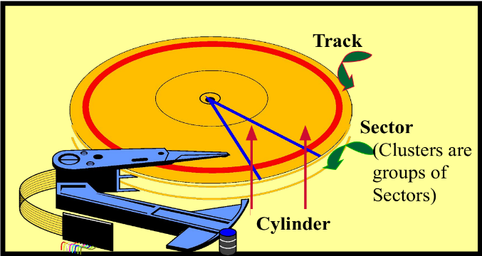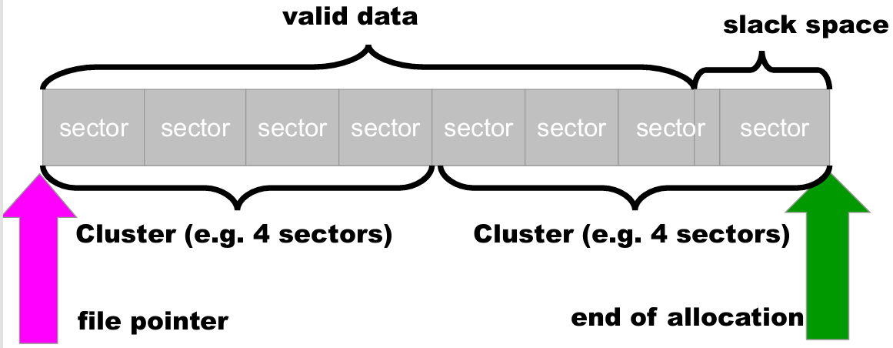
Track: circle on top of the disk
Sectors: block of disks that can only be red together. Minimum unit of physical memory. Size depends on the drive technology
Cylinder: set of tracks vertically aligned on various parts of the disk
Clusters: group of sectors consider as a logic unite from the file system
N. of clusters: depending on the technologies (generally 4)
The drive looks on group of clusters (NOT OF SECTORS).
Valid data new overwritten file. Valid data overwrites part of (or totally) an existent file. The two parts (valid data + slack space, part of the previous file) are independent.
The presence of the slack space allows us to acceed to the body of the old file, but not the header that will not be found anymore
A file gets splitted among (multiple) consecutive clusters. The last cluster might not be filled with the file. The non filled space, called slack space, will have parts of the old file. So, it is correct to say that the cluster is partially made by the last parts of the new file and something related to the old one
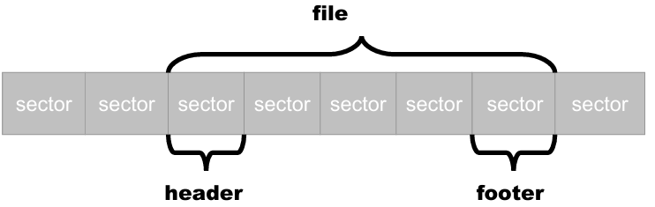
File recovery through carving:
- We scan the entire drive as a single bitstream
- We locate headers & footers of interesting filetypes. Anything in between, if not too large, can be the file we are looking for
- Issues:
- Techniques to determine filetype from content do not exist
- Fragmentation (but on modern large drives this is not common, if fragmented mostly 2-fragmented)
- (headerless) encryption and compression
ANTIFORENSIC TECHNIQUES
Antiforensic are techniques that aim to obstacle analyst’s job (lead them off track, or to defeat tools and techniques used by analyst). We distinguish between transient techniques, that can be defeated if detected, and definitive techniques that make it possible not to acquire evidence destroying them or making them impossible to acquirable or unreliable.
Critical failure points:
- Which are the technology-dependent phases? Generally, those techniques target the acquisition phase using tools for repeatable cloning and custody. Identification is another possible target, using tools for analysis of file systems, data reconstruction and carving
- Transient antiforensics if we interfere with identification, definitive antiforensics if we interfere with acquisition
Timeline Tampering
When analyst looks at a file system, a typical way is by timeline. Files have several timestamps (where they were created, modified, acceded MAC, Modified, Acceed, Change). We can therefore modify events by making them appear separated, or close, randomizing them or moving them completely out of scope. MAC allows us to know when the “last time that file has been touched”, making timestamp to be complete of information. In a timeline, the “most recent actions” are the “most reliable” to allow in understanding what happened.
Tool: “timestomp” (MACE) or “touch” (MAC)
They are antiforensics techniques because, once destroyed or modified, such data cannot be retrieved, modification not visible per se.
How to make files unrecoverable: we previously said what happens in the context of file deletion. In order to avoid this “slow behaviour”, we can “force” the overwrite using some specific utilities (heide, sdelete…) known as secure deletion utilities. There are also utilities that wipes unallocated space making it sure that only allocated files are there and spaces are wiped, including the unallocated part. Also, encryption is a technique, since encrypting a file (or a whole drive) takes care and protect only allocated data, it does not get involved with non-allocated data such as empty space, where portions of old files are present. So, when encrypting everything that has been deleted but it is still present in non-allocated space gets destroyed. Remember: when a data gets overwritten, it is gone.
Fileless attacks (definitive): If the traces are not on the disk at all and the machine is shut down, evidence is lost! If an attack runs this process and does not write anything, literally everything gets lost. There exist many tools that have functionalities that allows to do this kind of exploitation.
Filesystem Insertion and Subversion Technologies (transient): We place data where there's no reason to look for them, in particular inside filesystem metadata.
Log analysis (transient): Typically, you don't analyse logs by hand, but you use regular expressions or scripts. If attackers can inject stuff in the logs (very likely), they can try to make your scripts fail, or even to exploit them.
Analyst, very often, uses logs to retrieve timelines. Most of times it is used to see if there is something “unexpected” that happened by using some regular expressions.
Partition table tricks (transient): Partitions are generally not correctly aligned. Using a partition restore tool we can read them, but they may escape a forensic analyst.
Adding multiple extended partitions (Windows and Linux manage them, many forensic tools don't)-
Generate a high number n of logical partitions in an extended. With n high enough tools die
CHAPTER 8: SSD Technologies
Most of the drivers in our computes are SSD. They are flash memory chips used for mass storage. They used to be used only for small permanent storage, but “thanks” to their prices they progressively replaced the HDD by working for the same usages with a different, lighter technology. For a forensic point of view, there are lots of differences. HDD, magnetic drives used to last longer. SSD are made of cells and each of them have a lifetime. After a certain amount of cycles, they die. Cells are organized in blocks that, similar to sectors (but bigger), are seen as a whole block. The characteristic of blocks is that they can ONLY be read/written at once, we cannot change “a part” but we change the whole. Limited timestamp and having a “full” rewrite have several implications.
Flash Translation Layer FTL is a particular chip that has 2 jobs:
- Pretend for the OS that what it is using is a standard drive made of sectors and clusters
- Make the drive last as long as possible. In order to do this, it must do several things:
- Write caching In SSD, readings are faster than writings, as Writing: blink + write. Since of this writing behaviour, the idea to make this perform well is when a file has been deleted, what happens is to blank it “when it is time”. That move us to trimming
- Trimming 2nd big problem that SSD brings to forensic analysis. Delete unused data, operation made by the operating system
- Garbage Collection Similar to trimming, but it is the drive itself that figures out which data block to blank
- Data compression
- Data encryption/obfuscation
- Bad block handling when cell fails, isolate them to not use them anymore
- Wear leveling move around data so that rewrites get distributed equally across the drive.
FTL, thanks to trimming and wear leveling, “virtualizes” memory mapping and makes it look different from the O.S.

In HDDs we can reliably physically address a sector from the OS and read it on the drive. In SDDs, FTL translates logical block addresses (LBA) as requested by the OS into the respective physical block addresses (PBA) on memory chips. The underlying mapping is completely transparent and can be modified by the FTL at any time for any reason. The FTL may move data around or blank data even if the OS is not running. Most forensic approaches and tools rely on the ability of the OS to access the raw data on the disk
FTL CANNOT BE BYPASSED. there is no way to directly access the O.S. In theory, IT can be bypassed by reading directly the memory chips. But this is practically very complex to be done.
Mobile devices are a small exception since they do not have real FTLs, they have a system that “replicates” that behaviour.
Challenges in black box analysis: Previous work suggests impact on black box forensic analysis. Analyses file recovery rate (SSDs vs HDDs) observes that even a write blocker does not prevent the FTL from modifying and in some cases blanking the evidence and suggests a filesystem aware garbage collection feature in FTLs. SSDs tested with usage scenarios and concluded that different combinations of usage, OS and file size influence recoverability (most sensible and extensive paper to date) and found that carving didn’t work at all on SSDs.
Trimming is very effective: the entire drive gest trimmed in few seconds and data recovery turns to be impossible. The only case for this to happen is when the drive makes mistakes and leave some parts attached, but it is very rare to happen. Drives never shown behaviour of garbage collection.
CHAPTER 9: Evaluation and presentation
Those are step that are not actually intended to be technical.
Evaluation is the phase in which we match the elements extract from the evidence with what is needed to support a legal theory. This phase requires interacting with other professionals with different trainings and different points of view.
Items to evaluate:
- The elements to support the indictment! In Italy, the prosecutor is the magistrate that looks for the whole truth, not only proofs in his support
- Alternative explanations to the elements. Scientific experiments do not provide the whole truth; we need to find a “non-technical” explanation.
- Analysing what can be said, what cannot, and what further experiments would be needed to say more. The latter is important to analyse whether these experiments will be performed by the counterpart, and whether performing them or asking for them to be performed entails risk

Especially, we have to deal with lawyers. Relationship with them is important. He chooses the defence strategy, they are the ones to represent the client, they are the ones who decide what to write or say (You may be asked to omit a finding, as long as this omission is not the same as lying).

We also have to interact with the actual client, and our mandate is to find what helps to make him judged as not guilt. This is not the same as “helping someone escape law”: this is part of the due process of applying law. “Process truth” is not the same as historical truth

Sometimes, we might work with the prosecutors, or police. Obviously, working with a “superior entity” does not make us “morally superior”, we still have just to use our knowledge to retrieve information and report them. We still work on the same context but applying a different point of view.

Most of time we do not look for evidence, we analyse documents already presented in the process. We will look for technical errors, unclear reasoning or methodologies or descriptions, suggestive writings or opinions and hypotheses not clearly distinct from fact and not substantiated.

Typical technical and factual errors are:
- Acquisition Search and seizure (how was the information obtained): correct process, respected chain of custody (it, alone, means nothing unless we can prove It has been tampered but it is hard to do), seals; Description of seized/analysed materials: serial numbers, etc; Hashing/cloning procedure (e.g. use of write blockers)
- Analysis violation of element’s integrity; steps where hashing was not verified; Proprietary programs; bugs and vulnerabilities; Description of the process; Technical mistakes

Typical presentation errors:
- Lack exploration of alternative hypotheses It is common to limit to one explanation only, but what else, if there is, could explain the facts? What’s the best alternative theory, or the one tht best helps my vision?
- Is the presentation neutral or biased?
- Can we find counterexamples for some of the assumptions?
- Are there missing explanations that we can provide in order to shift the understanding of the judge?

So, when writing a report, the first and foremost aspect is to be clear. “Writing a lot” is not important if technical terminology, formal languages etc. are not comprehensible. It is important to be clear, simple in explaining what I have discovered and in explaining why it is relevant to the case and to reach a conclusion from the judge.
Report structure tips
- Model it on a scientific paper or report:
- Introduction tell them what you are going to say
- Facts
- Discussion and analysis each block with a small introduction saying what you want to explain and a conclusion summarizing what you just describe
- Final conclusions (generally, what a judge actually consider) leave out any doubtful statement: just distilled, iron truth
- Structure it like an obstacle course each obstacle a little taller than the previous one; make the judge sweat to ignore all your obstacles

Testimony as a witness in many jurisdictions the expert may just submit a report but may be called as witness. In others, like in Italy, they must be called as a witness and then submit their report. In most jurisdictions, the expert witness provides a sworn testimony and can commit perjury. This means that, depending on jurisdiction, an expert witness cannot lie or claim confidentiality or professional secrecy

Direct examination: Usually you are called by your side and thus proceed to friendly direct examination. Prepare a script with your side’s lawyer, be clear and very helpful, make sure you explain everything to the judge. In some jurisdictions (including Italy) judge can ask questions of their own
Cross examination: Examination by the counterpart is less friendly, sometimes downright hostile. Use your report as a shield and as a way to get time and think about the answer. Try to be curt, like replying as “yes/no”, and if you cannot, be very complex and difficult to understand

What not to do:
- Being too generic: “This does not work”. Why doesn’t it? Remember, the reader is not a technician
- Don’t “suggest”
- Don’t be too technical, you will not sound more expert, you will be ignored
- Don’t show bias or solidarity with your client. You are a scientist and must be cold and factual
- Don’t show excessive deference to the judge
- Avoid sarcasm (but if you are very sure of yourself and you want to aim low, you can use a little bit of irony)
- Don’t use weak arguments if you have more solid ones
CHAPTER 10: Cloud forensics
Recall the importance of Cloud in modern systems and its behaviour a service in different contexts: IaaS, PaaS, SaaS etc.
We will mainly deal with the public clouds, while private/internal cloud is a part not related to public management and runs in a closed environment. Generally, they have significantly less challenges.
Our goals are studying issues related acquisition and access to evidence, analysis and attribution (multi-tenancy systems and networks) and legal status.

Acquisition issues
Up to now, we focused on acquire the evidence as soon as possible and tamper them. In general, no control is given to user on hardware and storage space. We cannot have access to the hard drive to perform the standard acquisitions. Even virtual machines do not have them, so we must change the way we work. We would need to acquire as much information as possible from the host who is running the VM, but this is almost impossible since the VM can be spread to lots of users.
Levels of access vary:
- SaaS The cloud service provider is the only one who has access to log/data. Users can only use the application
- PaaS Users have access to a limited set of logs (application, network, database) or operating system features depend on the CSP
- IaaS Users have access to “everything” but remember that VM is not a physical drive. Virtualised drives do not preserve unallocated space for deleted files; network/ process logs at provider level (e.g. load balancer logs), they are not available to customers.

The real issue is that data do not really exist. Some data exists only as a result of a transaction. The problem is not finding the evidence, is that evidences themselves do not exist. We can reconstruct the operations thanks to the transaction proof, but we cannot reconstruct the details.
So, the main issue is that we cannot provide everything in court. Some data will not be available; metadata can easily disappear. What can be a good compromise is to perform an investigation on a hypervisor-level, but tools are generally weak and not open source. We can try to see what happens on the guest VM.
In any investigation that is connected to the cyberspace, attribution is hard already. Usually, we start from an event and spoofing the IP address. Next, derive usages and behaviours, define user’s identity, who he is and what and why he does, where he is and any other relevant information. But something can go wrong. For example, who is the real owner of the computer? What if it was infected by a virus? If a component is compromised, everything related to it becomes and data becomes unreliable

This is all problems in attribution to internet. In a cloud infrastructure, only the cloud provider can connect the IP to the VM, they’re the only one who can allow us access to the computer. This indirect access can result problematic in detecting the location and the identities, for example.

From a juridical perspective, many issues come out:
- Geographic location Some judiciary acts require a physical location, that is masked in a virtual environment
- Electronic data is unique as it may actually span multiple physical locations! ○ No other artifact has, or ever had, this property
- Under “Budapest convention” support for the concept of “Electronic Search and Seizure”, it is “easier” to deal with cross border crimes, that are generally more bureaucratic to deal with
- Contract and SLA issues with CSP

Many laws require companies to be forensically enabled (forensically friendly), to allow reconstruct evidence. If the environment is hosted in a cloud environment, this has to be translated in a cloud service provider. There are several providers available to make a service forensic friendly as:
- Make an effort to store volatile VM data in their infrastructure
- Make an effort to provide proof of past data possession
- Data location
- Identity Management
- Encryption and Key Management
- Legal provision and SLAs

In conclusion, cloud enabled forensics have the following advantages and disadvantages:
- Large scale data storage
- Large scale computing infrastructure
- Reuse of computing concepts (e.g. map-reduce, etc.)
- Loss of control on evidence (privacy issues)
- Chain of custody (same challenges as for acquisition)
- Transnational operations are challenging from legal perspective
EXTRA: CYBER INCIDENT RESPONSE
A cybersecurity incident is an occurrence that violates the integrity, condifendiality or availability of an information system or threat of violation of laws and security policies.
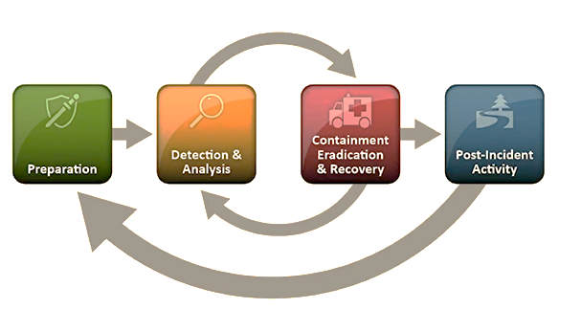
Incident response life cycle can be modeled as follow:
Preparation prepare tools and system to properly detect attacks
Detection and analysis an anomalous behaviour is detected
Containment eradication and recovery procedures to protect the system
Post-incident activity review security controls to be sure that incident do not happen again

Companies should have an Incident Response Plan. Here, it is generally defined worker’s roles and responibilities, critical incidentc, computer forensics procedures and other policies.

Standard security tools are Antiviruses, firewalls, Security Information and Event Management (SIEM), that describe laws and specific requestes and rules to follow.
To perform a good analysis, it is then impor tant to collect laws, to understand what are the motivations for such attacks, to understard the laws, create alert to spot malicious activities.
An attack can be “measured” by the Dwell Time, number of days an attacker is present before the detection.
When an attack is performed, whe have to follow some steps to perform to preserve and isolate the system, kick out the threat actor, decide how to contain the system (if it is prefered to contain the compromised part or preserve the safe one).
Eventually, learn from the experience and adapt internal policies.
Modern incidents involve VPN exploitation, phising attacks and stole user credentials to log into users accounts.
Computer forensics comes to be very helpful, when well done and managed it ensure data preservation and a formal way to acquire them. On the other hand, acquisition is time consuming, sometimes physical access are required, and in case of large incidents it is hard to scale; computer forensics investigation might face some companies needs that make the jobs harder (serves to turn off for a certain time, for example).
A strong tool that can help us is the EDR (), whose characteristics are well suited for a digital forensic context:
- No need to power off the host
- Real time analysis at scale
- Remotely retrieve information from the hosts
- Can be used for containment
- Can search for Indicatort of Compromise (IoC) such as file names, hashes, Ips
- Have signatures to spot malicious activities
- Can Import Cyber Threat Intelligence Information
Moving back to what we should have in mind, when making investigation it is also important for us to study the threat profile and modeling: who can be the relevant threat actors, their positions, why they want to attack and how
Threat Hunting
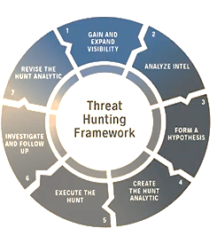
The basic concepts to start with are data collection: determine needed sources, network and security tools available, what of them do what I need. Generaly, centralized logs for 1 yer is a best practice to ensure to go bck in time and “retrohunt”.
Then, develop hunt hypothesis and exploit Cyber Threat Intelligence to help look for proofs and understad usual/unusual pattern in an environment.
Next, collect and analyse the information and determine the impact of the attack in the compromised environment
Methods for Cyber Threat Attribution
Attributing cyber attacks is complex, but time to attribute them and indicate who the cyber threat is is important for economic, military, political interests. Empirical analysis for cyber attribution are not generally public, but some pattern that can be recognized are:
- Rank methods to verify which are the most recurrent ones and the constraint that should be kept in mind when dealing with them
- Verify the most recurring values for each method
- Time and time-zone analysis, useful to the determine when and where the attacker operates
EXTRA: MOBILE FORENSICS
Mobile forensics is utilization of scientific metholodologies to recover data stored in a mobile device under forensically sound conditions using legal methods. Mobile devices are basically the same we use every days, such ash amrtphones, tablets, but also wearabale (smartwatch), IoT, VR, GPS devices and similar. Each mobile device has its own tools and each one has to be treated independently.
Historically, the first features under potential attacks were general information, phonebooks, call history, sms, audios…
The first smartphones introduced new informations, like web navigation, emails, calendars… up to now, where we store also our biometric data, passwords, GPS and health informations…
Nowadays, everyone has a mobile phone and every single person can be victim of an attack.

Components that we need to extract and analyze are:
- Internal device memory where almost all relevant data are stored
- SIM card only used to provide internet connections; not anymore used to store data like SMS
- SD cards External memories, nowadays less used
- Cloud sync Nowaadys, it is very common for everyone to store our media on cloud services
- Local backups Sort of untampered evidences
- Synched deviced more devices connected to the same account, so that from one we can track and monitor all the others

The most crucial aspect is encryption. In the “pre-smartphone era”, mobile devices lacked encryption mechanisms, leaving users data vulnerable to attacks. Now data are actually encrypted in various ways depending on the OS, developers etc. But a common pattern is the usage of a 2FA, biomedric encryptions…
Encryption as managed by Android and iOS, the process of encoding all the data using symmetric encyrption keys. Once a device is enctypted, all the user data are autmatically encrypted before committing to the disk.
Android exploit 2 technologies:
- FDE Full Disk Encryption Encode all users data using an enctypted key. Introduced in android 4.4, but available up to Android 9. From 10 to 12’s versions, FDE can be used if they are upgrades of a phone whose native android version is suitable. From Android 13, FDE disappeared
- FBE File Based Encryption Different file can be encrypted with different keys and unclocked independently. Available for all Android version higher than 10. It enables a feature, direct boot, that allows encrypted devices to boot straight to the lock screem. In has two storage locations:
- Credential Encrypted CE files, available onky after the user unlccoks the device
- Device Encrypted DE file, available during Direct Boot (phase when a phone is turned on) mode and after the user unlocks the device

FDE and FBE both makes “old physical methods” not viable because of encryption keys. FDE has a fikes decryption key, while FBE uses different keys independetly making it very hard to recover deleted files, almost impossible.
FDE passwords are likely to be pins, while patterns FBE do not need to know the passcode. FDE, if secure startup is enabled, needs me to know/atack the pin, while FBE ties passcodes to CE files, so you need to know/attack the pin/pattern to decrypt

iOS works using a technology, Data Protection, where every single file has an encryption key and each file has a 4 encryption levels, classes, each one with a policy to determine when the data is accessible. The class is assigned by the app that creates the file:
- Class A Complete protection
- Class B Protected unless the data is opened
- Class C Protected until the first user authentication (user unlocks the phone), used to encrypt almost all the data
- Class D No protection (Not supported in Mac), similar to DE on Android

The first thing to do in a mobile forensic process is to check is the device state (no passcode, known passcode, turned on with unknown password = unlocked AFU (after first unlock), turned off with unknown passcode = never unlocked (BFU before first unlock)), then look for device informations and warranty status. Device connection is the next crucial step. In fact, to extract data from a device we need to communicate with it. Typically, we do it via USB. Sometimes, phones has to be physically unlocked to allow the communication; in some cases we have to rely on another method (bluetooth, WI-FI). Then, get to device acquisition. Extraction is affected by the state (Known password, Unknown with AFU, Unckown password with BFU that is the hardest case and might require brute force to guess the passcode or limit to class D/DE enc data)

Acquisition tools: free/opensources are typically restricted and allow to extract only some basic data without exploitation. Commercial tools allows to extract some specific data from devices thanks to exploit techniques. Lastly, Advanced tools, that has access to the full system and to the passwords. Graykey are an example of devices that tries to bruteforce passcodes without triggering securityprotection mechanisms.

Once the data is acquire, we need to analyse them. Both Android and iOS have applications (either native or third parties) that help us in the analysis and in data extraction. Typically, it is not requored to have a digital forensics background. Last step is to make the data valid to be used in court contexts.
EXTRA: CYBER ESPIONGE CASE STUDY
In general, as we told lots of times, attacker are people with motivations (financial, strength proof etc.)
that tries to break security systems. An attack can be described with this example of anatomy, based on the real case Strontium:
- Threat actors targets employees via phishing attack
- An employee opens the malicious message/email and the threat agent has full access to the data that employee is authorized to
- Exploiting workstations, threat actors persists malware and gather more credentials
- Threat actors use stolen credentials to gain unsolicited access and compromise the system infrastructure
- Threat actors encrypt sensitive business data

A cyber incident lifecycle can be summarized as follow:
- Support case triages and determines best course of action First investigaion. It generally lasts few hours/days
- Incident Response diagnosis of the issue and immediate actions. It generally lasts 1-2 weeks
- Compromise Recovery immediate options for getting to a recovered state. It generally lasts 6-8 weeks
- Strategic Recovery prescribed road ahead to ensure safety. It can last severa months

A key goal in investigation is to findi IoC (Indicators of Compromise) and ABCs (Accounts, Backdoors, C2 Channels), that consists in compromisd privileged accounts, systems, or creation of “regular users” to break security systems; system control enabling without compromising credentials and reporting back to the C2 (Command and Control) servers on the internet.

Modern, real world systems hunt threats by means of automatic detection, fenerally AI/ML based, that identify high risk activities. Once detected, “real people” investigate and analyse the results and provide geedbacks that improves autonomous detectors.
User Entity Behavior Analytics (UEBA) solutions use analytics to build the standard profiles and behaviors of users and entities (hosts, applications, network traffic and data repositories) across time and peer group horizons. Activity that is anomalous to these standard baselines is presented as suspicious.
EXTRA: CASI DI INTERESSE IN ITALIA
Forensics si traduce comunemente come forense, ma è un evidente anglismo. In italiano forense significa “relativo al tribunale”. Tuttavia, è ormai riconosciuto nell'uso comune: patologia forense, informatica forense. La traduzione corretta del termine in italiano è criminalistica, ovvero l'applicazione di una disciplina scientifica all'analisi del crimine. Quindi si potrebbe dire (ma non si dice) “criminalistica informatica”.
Nel diritto penale italiano, il termine “ripetibile” ha un significato tecnico che vedremo insieme. Attenzione a non confondervi tra il significato “scientifico” (esperimento può essere rifatto allo stesso modo e produrre lo stesso risultato e un altro esperto può analizzarlo e convincersi che funziona senza necessità di rifarlo) e quello tecnico. Nel diritto penale italiano, la “prova” è quella che si forma nel dibattimento di fronte al giudice. Quindi il termine evidence va tradotto come elementi probatori.

Il concetto di “catena di custodia” in italiano non esiste, mentre invece risulta fondamentale nel diritto americano. In Italia, la valutazione degli elementi probatori è fatta dal giudice, come vuole la convenzione di Budapest riguardo la criminalità informatica. Altri concetti riguardano il mantenimento della validità della prova, o i giudici intervengono per “risolvere buchi di trama” basandosi su quanto analizzato e raccolto
Tornando al concetto di ripetibilità, dal punto di vista penale è legato alla Possibilità effettiva di ripetere la pratica. Nella fase del processo penale, si fa riferimento all’articolo 359 del codice penale processuale (359 cpp): Il pubblico ministero, quando procede ad accertamenti, rilievi segnaletici, descrittivi o fotografici e ad ogni altra operazione tecnica per cui sono necessarie specifiche competenze, può nominare e avvalersi di consulenti, che non possono rifiutare la loro opera.
Quindi il pubblico ministero può avvalersi di consulenti tecnici, che non può rifutarsi poiché è necessaria la sua competenza per procedere con le analisi
Questo vale in generale. Per casi specifici di eventi “irripetibili”, questi sono regolamentati invece dall’articolo 260 del cpp:
“Quando gli accertamenti previsti dall’art. 359 riguardano persone, cose o luoghi il cui stato è soggetto a modificazione, il pubblico ministero avvisa, senza ritardo, la persona sottoposta alle indagini, … della facoltà di nominare consulenti tecnici.
I difensori nonché i c.t. eventualmente nominati hanno diritto di assistere al conferimento dell'incarico, di partecipare agli accertamenti e di formulare osservazioni (coomenti) e riserve (cose su cui si deve esprimere un guidice o si deve fare ricorso).
Qualora, prima del conferimento dell'incarico, la persona sottoposta alle indagini formuli riserva di promuovere incidente probatorio, il p.m dispone che non si proceda agli accertamenti salvo che questi, se differiti, non possano più essere utilmente compiuti. (a pena di inutilizzabilità, 4o comma)”
In tal caso l’eventuale indagato può e deve essere informato sul fatto che è sottoposto ad indagini in modo che possa essergli data la possibilità di nominare un difensore
Exam questions
Threat landscape Part
Define the term “ransomware”. What are the typical components of the cybercrime ecosystem behind a ransomware attack? What is the role of cryptocurrencies in the ransomware phenomenon?

Ransomwares are an example of Malware that consist in partially/totally block the victim’s computer and files by means of an attacker, that then will ask for a ransom to make them usable again. Each ransomware is differently developed from the others, but typically they consist in encryption/decryption approaches. So, as main actors we can call the attacker himself, the ransomware developers, a malicious server where the decryption happens and a database where to store the encrypted informations. Cryptocurrencies are helpful as it is common for criminals to ask for the ransom by accepting cryptovalues only, as transaction that occur in this environment are irreversible: once the attacker receives the money and the transaction succesfully ended, it cannot be reversed.
Cryptocurrency Part
Describe what it is a Bitcoin, what it is a Bitcoin Wallet and the bitcoin life cycle

Bitcoins are a decentralized, distributed database used to manage transactions (ledger). A Bitcoin Waller is a software that, for each user’s address, manages the pair of public/private keys associated to him for signing and validating transactions. To describe bitcoin’s life cycle, we stard by defining transactions as an exchange of money between User A (sender) and User B (receiver):
User A opens his wallet and decides which public key use to send money (notice that each user might have multiple keys), the wallet sign the transaction by using the correct private key and send it over the network. Here, miners will validate the transaction by solving a proof of work and, if everything is ok, it is included in a block which becomes part of the blockchain and User B will receive a notification of successfull transaction
ML Part
Provide a definition of fraud, highlighting and describing its main characteristics

A fraud is a malicious action aimed at obtaining unlawful or unfair gain, often financial, by misrepresenting or concealing information. Frauds main characteristics are:
- Uncommon Low historical examples to study in order to prevent them
- Perfectly concealed In order to not be detected by potential automated detector and remain hidden even to expert analysis, they interaction tries to appear as similar as possible to a non fraudolent one
- Time evolving frauds are dynamic phenomenon, they constantly change in form, shapes and behaviour in order to not be detected in close times

Describe the fraud analytical process model, highlighting the core featurs and challenges of each step

First step in fraud analytical process is to identify the problem and understand the context where it happened and why. Then, proceed in data analysis, that consist in collecting them, choose which one are relevant for our purposes, fix potential data issues (outliers, missing values etc.) and adapt them in order to be suited for the ML model we want to design. Next, the model will be realised based on the kind of data collected and how, choosing from several approaches (supervised/unsupervised learning). Finally, the model is deployed and monitored in production to detect fraud in real time

Describe the main components of an anti-fraud strategy, providing a brief explanation of how they work, advantages, and disadvantages.

The two main anti-fraud strategies are fraud detection and fraud prevention. Fraud detection analyzes transactions or behavior in real time or offline to identify anomalies using rules, statistics, or ML models. It catches new or unknown fraud patterns after they occur, but loss may occur before detection.
On the other hand, prevention consists in build models based on previous fraudolent attacks to make the system strong against similar ones that can occu. It can reduce attack surface and losses but it can reject legitimate users (false positives) and may fail against novel attack types.

Describe the Fraud Management Cycle, highlighting the core components and challenges of each step.

Fraud management cycle consists in 4+1 main steps:
- Fraud detection: new, unseen observation are detected by the model. Here, we still do not know if they are malicious or not
- Fraud investigation and confirmation: An expert analyses the observation and, based on his knowledge, confirms whether it is fraudolent or not
- Fraud prevention: prevent future similar attack, or ones that follows the same pattern, to occur. Obviously, frauds change constantly and this stage might be irrelevant in few times
- Upgrade on the fraud detection model by adding the observation to the model’s historical database used for detection. Careful on choosing the correct data and the correct amount to avoid overfitting

Explain why fraud detection is typically considered an imbalanced class problem. Additionally, describe the appropriate management strategies for this issue, focusing on sampling techniques and the performance metrics that should be used

Fraud detection is an imbalanced class problem because fraudulent transactions are extremely rare compared to legitimate ones, making standard classifiers biased toward the majority class. Sampling techniques:
- Oversampling: increase fraudster samples and gain more examples, but overfitting can easily occur
- Undersampling: reduce non fraudolent samples. It balances the dataset but loss of information can cause the model to be unprecise
- Combination (Hybrid): of th etwo models to have a correct balance without data loss
Performance metrics:
- Precision: look, from the flagged fraudolent, which really are
- Sensitivity: which, from the fraudolemt transactions, are actually detected
- F1-score: balance precision and sensitivity
Describe pros and cons of Expert-Based Static Rules systems

Expert-based systems are systems built by hand by analysts and domain experts. They cooperate on looking on data collection, relevancy of informations and methods to secure strong systems. Their disadvantages concern time, as there are lots of data to study from and by the time the model is ready it might be unusable due to change in the attack models and on data analysis (underfitting and overfitting issues, data quality)

Describe the problems of Black-Box models in the fraud detection domain and how the problem can be mitigated

Black-box models are often accurate but hard to interpret, making it difficult to explain, debug, or comply with regulations, and they may overfit or rely on spurious correlations. Mitigation strategies include explainable AI techniques, hybrid models combining interpretable and complex methods, and simplifying models to improve transparency.
Introduction to Digital Forensics Part
Describe what is intendet with “scientific”, define the chain of custody concept

With scientific, we intend experiments that satisfy repeatability (other domain experts can repeat the same procedures with the same inputs, resulting in the same observations and conclusions) and falsifiability (any observation that provides a result that falsify a statement. Remind that scientific is not a matter of true/false). Chain of custody is a concept that legally handles data acquisition in the USA jurisdiction, ensuring data authentication, integrity and security

What does it mean, for a digital evidence, to be brittle? How can we limit this problem?
Digital evidence are brittle, in the sense that it is easy to tamper them and make them unreliable in court. A strategy to limit the problem is performing data acquisition without altering original sources, and to prove data integrity and validity we can exploit file hashes, that completely changes when a file is modified. It can tell us the last time a file has been used, as new hashes will indicate that changes has been done after acquisition. Careful that they cannot help on telling us what happened before the acquisition

What is, in brief, the Daubert Test?

Daubert test is a model used to establish criteria for admissibility of expert testimony. Each different countries have their own laws and their jurisdiction, so to have a standard for digital investigations, it is considered that a digital investigator can testity when his observation are based on well known and recognized scientific reasoning, and opinions must be objective and based on reliable methods, not biased toward one side
Source acquisition Part
Describe what is a write blocker, describe a process to clone a disk using a write blocker appropriately and describe an example of a case in which a write blocker may prove not useful.
Describe the “alternative procedures” with respect to the standard one

Write blockers are hardware devices that allow to make a perfect copy of files and data sources without tampering the original ones. This procedure is identified as bit-to-bit stream image, and works as follow: first, the sources are disconnected from the original computer (if possible, for example turning it off). Then, we first recover the hash of the source, create the copy in our write block and recompute both the hashes of the original and copied files. If all the three matches, everything is ok.
Write blockers are useless in contexts where we cannot turn the device off (for example, a server) or in the case of SSD disks that works with FTLs, making it impossible to directly connect to the informations in the disk. The alternative procedures consists in a live analysis of the informations and to study the user’s behaviour and see if it can be detected a strange behaviour at a certain point

In which case is it preferable to proceed with an acquisition using a live Linux distribution instead of the standard process? Explain how it works

Using a live Linux distribution is preferable when it is not possible to turn the machine off to remove the storage device for a standard forensic acquisition. This situation typically occurs with systems that must remain operational, such as critical servers, workstations running important processes, or computers protected by full-disk encryption that would lose access keys if powered down. In such cases, a live Linux distribution is booted directly from an external medium, such as a USB stick or DVD, without modifying the content of the internal drives. The system loads entirely into memory, allowing investigators to access the disk in read-only mode and to create a forensic image while minimizing alterations to the original data. This method preserves volatile information, such as active processes or encryption keys stored in RAM, which would otherwise be lost during shutdown.
Identification Part
What does “anti-forensics” mean? What are the two main types of anti-forensic techniques? Give at least one example per each.

Anti-forensics are techniques exploited by malicious actors to interfere with and make forensic investigations harder or even impossible. They can be classified as transient techniques, which can be mitigated if properly detected (example: log injection, consisting of injecting code to make investigation software fail or placing relevant information where it is not common to look for) and definitive techniques, which aim at destroying evidence (example: fileless attack, consisting of deleting sources, which first deallocates the data from the respective metadata while still leaving them present on the disk, and then shutting the computer off. When this happens, everything that is deallocated becomes permanently lost).

Explain how it is often possible to recover deleted data, touching on the concepts of file allocation and deallocation, metadata persistence, file carving and slack space.
(Other format of the same question: Describe how FS works on an HDD, describe carving space and slack space and how those properties can be exploited in the context of data recovery)

In the Unix context, when a file is deleted by a user, what actually gets removed is its metadata, which contains pointers to the physical locations on disk where the real information is stored. The data itself is not immediately erased and remains present on the disk until it is overwritten. HDDs organize storage space into sectors, which hold portions of data such as headers, content, footers, and slack space used to access them. Groups of sectors form clusters, which are the units the drive reads from the disk. File recovery can be performed by directly reading these clusters. Even if the metadata has been deleted, specialized techniques can identify a deleted file’s header and footer, allowing the content in between to be reconstructed — this is known as file carving. In some cases, when deallocated space is partially overwritten by new data, fragments of the old files can still be recovered, providing at least partial information to work with.

SSD Part
In SSD drives, what is an FTL chip? What are the behaviors of FTL chips that can interfere with forensic acquisition and analysis, and how?

In SSDs, Flash Translation Layer (FTL) is a controller chip that manages how data is written to the NAND flash memory. Unlike traditional hard disks, SSDs cannot simply overwrite data in place; instead, the FTL maps logical block addresses (LBA) from the operating system to physical locations in the flash cells (PBA), performing wear leveling, garbage collection or trimming, and error correction in the background. These internal processes are opaque to the user and to most forensic tools. This can interfere with forensic acquisition because deleted data may be permanently erased by the controller even before an investigator accesses the drive. Features such as TRIM, which proactively clears unused blocks, and the remapping of bad blocks, can result in evidence being destroyed or moved without leaving predictable traces. Consequently, bit-by-bit imaging of an SSD does not guarantee the same completeness as with HDDs, since the logical view exposed by the FTL may no longer correspond to the original physical data layout.
Cloud Forensics Part
What are the main challenges in the forensic acquisition of a webpage, and what are the approaches and countermeasures that can be adopted to solve or mitigate them?

The main issues in forensic acquisition of a webpage come from the volatile and dynamic nature of web content, which may change rapidly, differ depending on user sessions, or be stored in virtualized environments where it can be modified without leaving clear traces. This makes it harder to ensure data integrity and to prove that the acquired content is an exact representation of what was originally displayed. Webpages can also be manipulated through anti-forensic techniques, such as obfuscation or redirection, which further complicate analysis. To mitigate these problems, investigators typically use timestamping and hashing to certify the acquisition, rely on tools that capture the full content of the page rather than just screenshots, and when possible employ third-party certification to strengthen evidentiary value.

